**Oracle to Redshift Migration**

[For better reading, set page’s zoom between 180x and 200x]

This lab demonstrates how we can use AWS Schema Conversion Tool (AWS SCT) and AWS Database Migration Service (DMS) to migrate data and code (DDL structures and the PL/SQL code) from an Oracle database to Amazon Redshift. It also demonstrates how to use AWS DMS to continually replicate database changes (ongoing updates) from the source database to the target database and how you can leverage AWS SCT Extractor Agents to address different migration scenarios.

**Prerequisites**

* **Region must be us-east-1 (N. Virginia)** for the template and lab to work without issues.
* A new VPC will be created via Cloud Formation Template in that region. **Make sure you have one VPC slot available** to be created (Limit is 5 per region per account)
* **Remote Desktop Client should be installed** - If you do not have a Remote Desktop client installed, you can use the instructions on this [link](https://docs.aws.amazon.com/AWSEC2/latest/WindowsGuide/connecting_to_windows_instance.html) to do install it for Windows, Mac and Linux.
* **To avoid Lake Formation permission issues,** before running the CFN template, go to [AWS Lake Formation Console](https://console.aws.amazon.com/lakeformation/home?region=us-east-1#administrative-roles-and-tasks) - and under Data Lake Administrators specify the principal that you are using to launch the CFN template as one of the LF Admin.

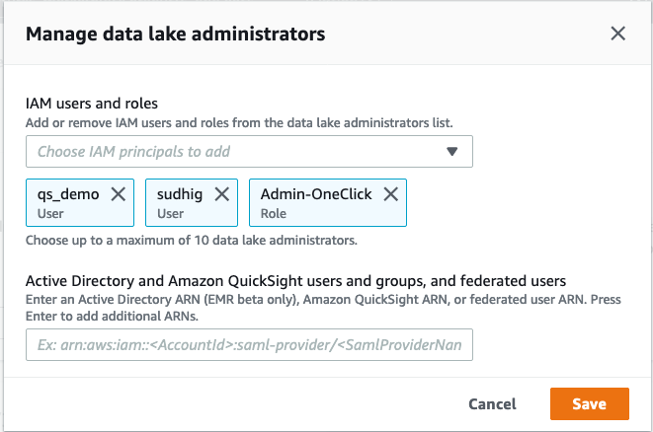

**Architecture**

To solve the challenge, here is the architecture that you would be going through in this lab:

* AWS DMS replication instance: This instance will take care of migrating data from source to target databases
* Oracle RDS database: This will be the source database for this migration lab
* Amazon Redshift cluster: This will be the target database for this migration lab
* Windows EC2 client: This windows instance will serve as our workstation, where you’ll have all softwares and tools
* Associated networking resources

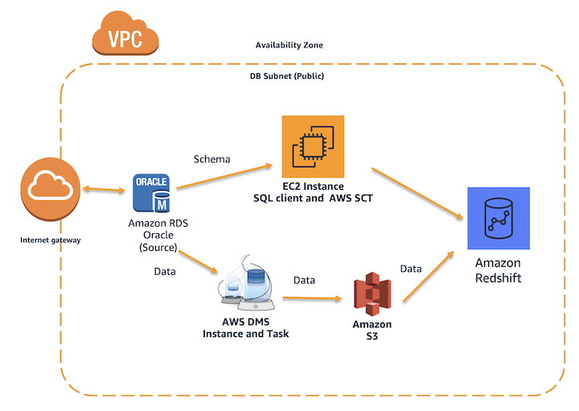

**Environment Setup**

**Cloud Formation:**

Open the Cloud Formation Console, select Create Stack (with new resources), choose “Template is ready” and “Upload a template file” option, then upload the YAML file previously shared (**lab11-fixed.yaml**).

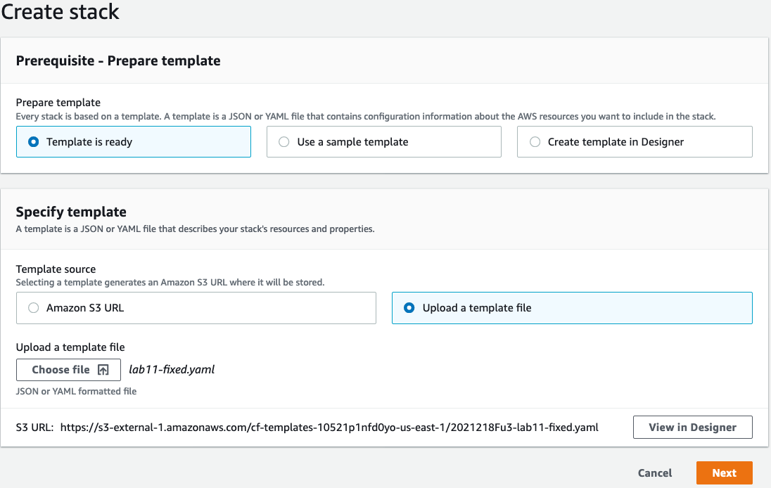

Hit next, give the stack a name (Oracle-Redshift-Lab), hit Next two more times and scroll down to the bottom of the page. Select the “**I acknowledge that AWS CloudFormation might create IAM resources with custom names**” checkbox and click on Create Stack. Wait until all resources are provisioned and stack status change to “CREATE_COMPLETE”. (Approximately 15 minutes to create all the resources)

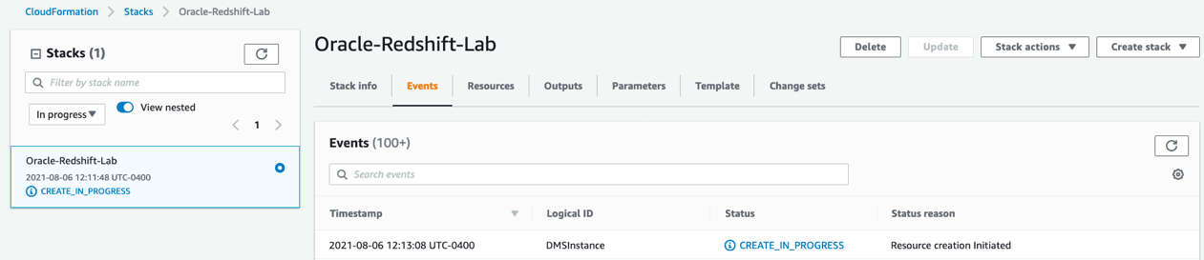

Once template is completed, extract all the Output Information from Cloud Formation Output tab (passwords, endpoints, etc):

EC2DeveloperPassword: <get from CF Output tab>  
EC2HostName: <get from Output tab>

RedshiftClusterEndpoint: <j from CF Output tab>  
RedshiftClusterDatabase: dev  
RedshiftClusterPassword: <get from CF Output tab>  
RedshiftClusterPort: 5439  
RedshiftClusterUser: demo

RedshiftClusterJDBCEndpoint: <get from CF Output tab>

SourceOracleEndpoint: <get from CF Output tab>  
SourceOracleSID: ORACLEDB

SourceOracleUser: dbmaster  
SourceOraclePassword: Password1

(Feel free to populate the fields here in this word document for easy access later on)

**Remote Desktop Client:**

Make sure you select the best resolution for your screen in RDP. You can try the options “Fit Session to Window” and “No full screen”, this helps you switching back and forth between RDP and your Browser. Also make sure that “Share Clipboard” option in RDP is select so you can copy and paste.

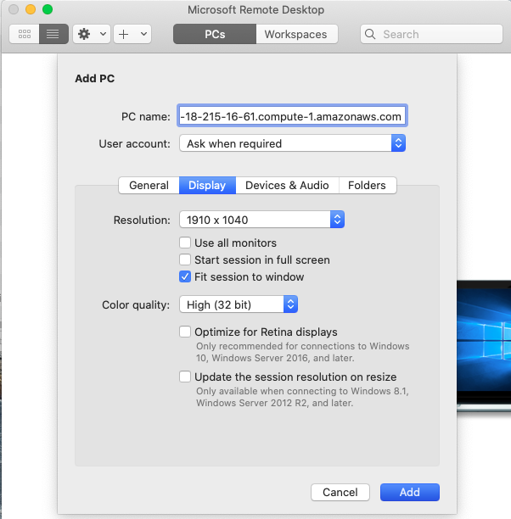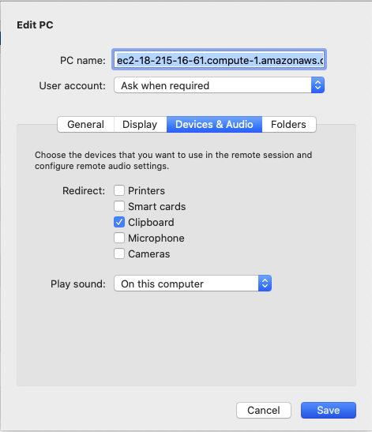

**1. Convert the Schema**

In this section, you’ll take care of migrating code and data structures from the source Oracle database to Amazon Redshift Datawarehouse using AWS Schema Conversion Tool. This includes the table definitions, stored procedures, views and other database objects.

1.1. To start with the migration, first you’ll need to login to the windows EC2 instance using it’s IP address or public endpoint. You may use Windows Remote Desktop client (RDP) tool to login to that instance. RDP default’s user is Administrator, change to developer as in the below information.

Remote Desktop Host: [EC2-Client-Endpoint]

Username: developer

Passowrd: <get from CF Output tab>

1.2. Once logged in, use the Windows Flag (Start) button to find the AWS Schema Conversion Tool and initiate a new project. Click File> New project> Data Warehouse(OLAP) > Ok. Then select OLAP followed by Oracle DW.

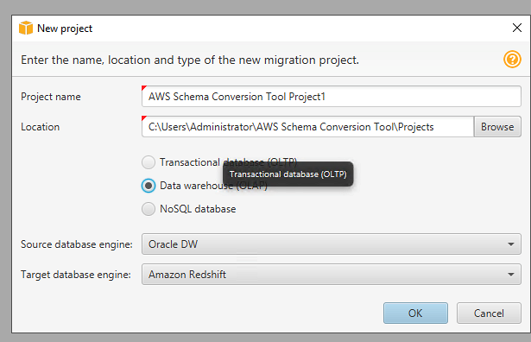

1.3. Now, you need to configure the connectivity for the Oracle source system. Click Connect to Oracle DW, then Input below parameters and Click Test. It should show connection successful:

Servername: [Oracle-Endpoint] <get from CF Output tab>

port: 1521

SID: ORACLEDB

Username: dbmaster

Password: Password1

Oracle Driver Path: C:\DMS Workshop\JDBC\ojdbc8.jar

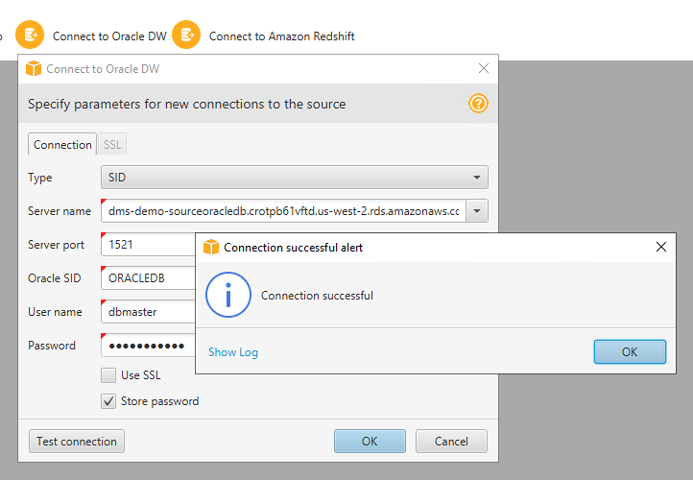

1.4. By default, AWS SCT uses AWS Glue as ETL solution for the migration. You will need to disable it as it’s not being used in this lab. Click Settings then select Project Settings

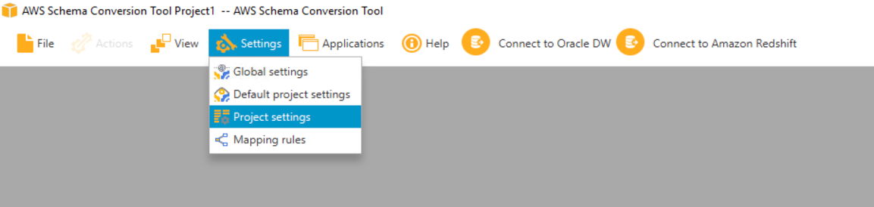

Uncheck Use AWS Glue. Click OK after that.

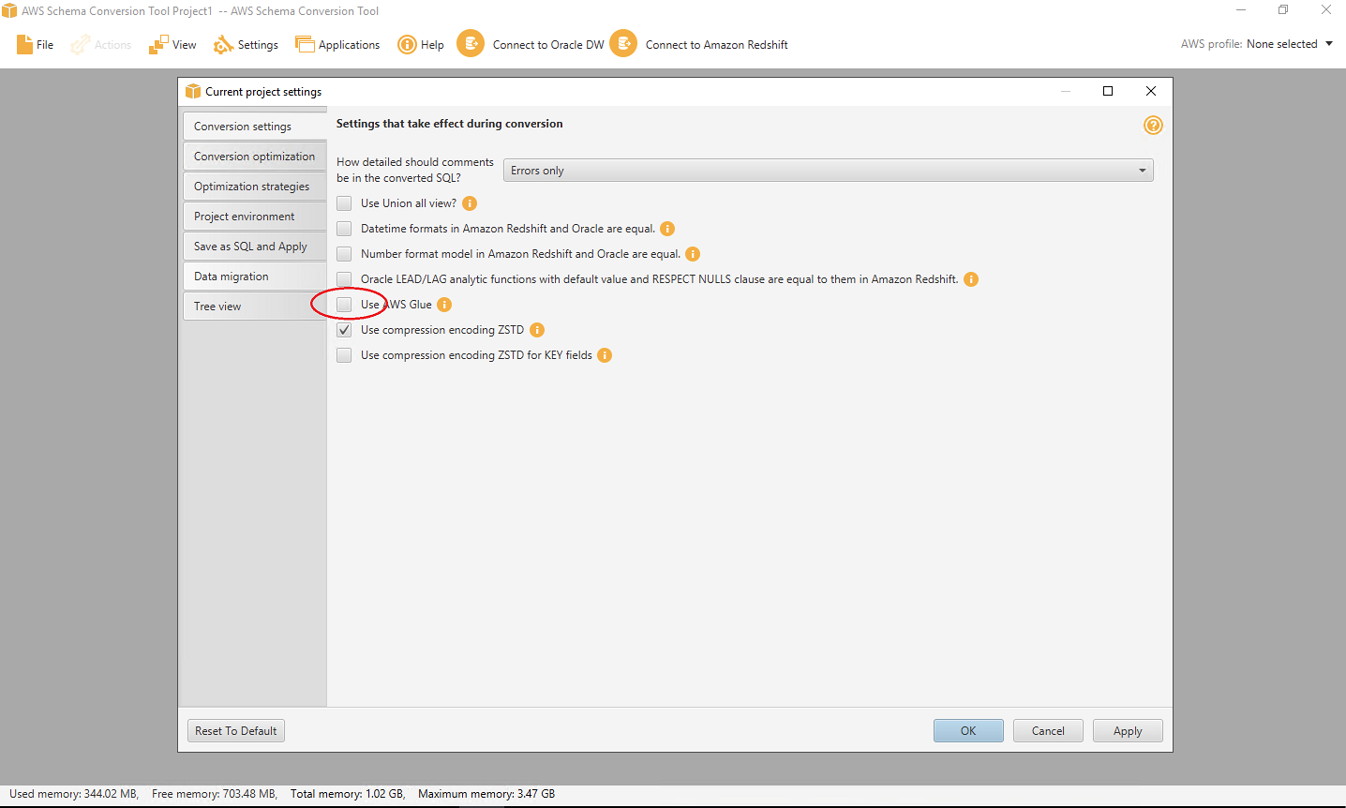

1.5. Now, you need to configure the connectivity for the target system, Redshift. Input below parameters in the connection Tab and then click Test.

Servername: [Redshift-Endpoint] <get from CF Output tab>

Port: 5439

Database: dev

Username: demo

Password: <get from CF Output tab>

Redshift Driver Path: C:\DMS Workshop\JDBC\RedshiftJDBC42-1.2.43.1067.jar

It should show connection successful.

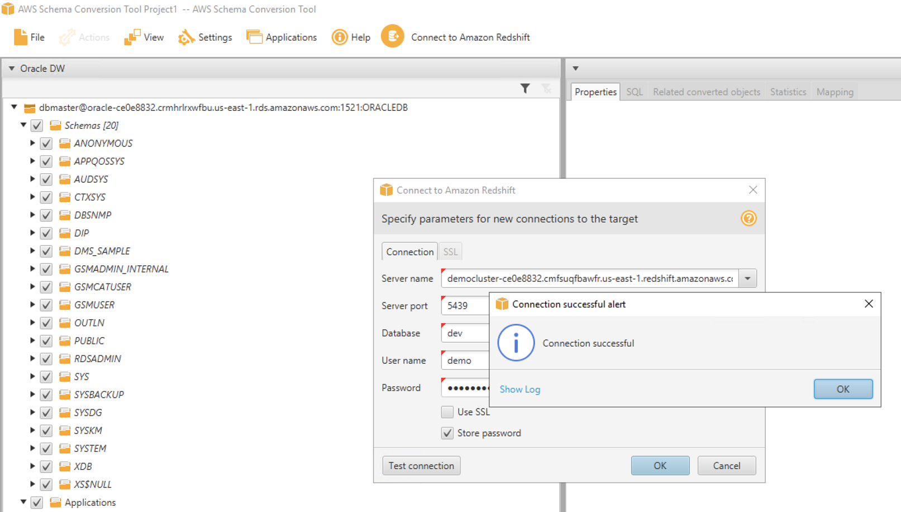

1.6. On the left-hand side, you can see all objects in Oracle and on the right-hand side, all Redshift objects. you may now convert the Oracle schema DMS_SAMPLE. Right click DMS_SAMPLE schema and then click convert schema. After that, click the default options Yes and Continue when prompted on the next screens about already existing objects and source database statistics.

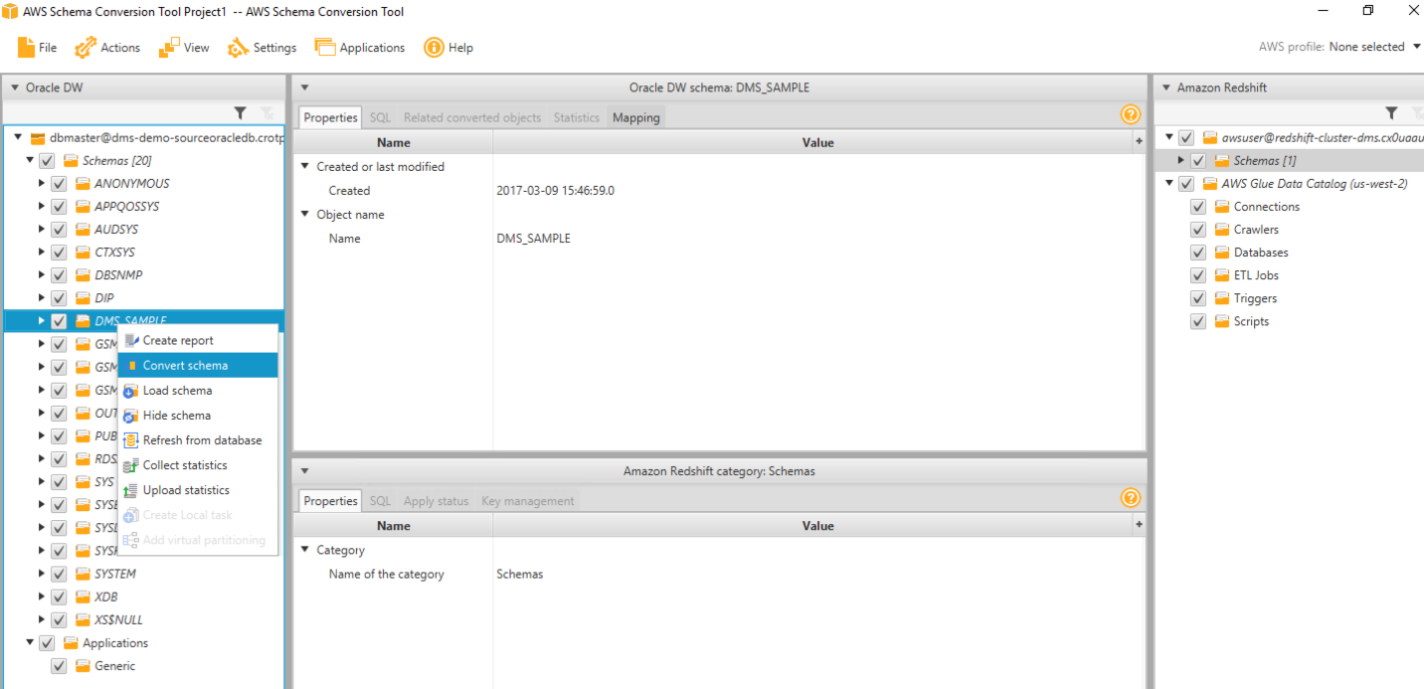

1.7. All Oracle objects should get converted to Redshift syntax by now. But there would be some objects showing in Red, which essentially means that SCT couldn’t fully migrate these objects. You can view an assessment summary for the migration to analyze those objects. Click View > Assessment Report View:

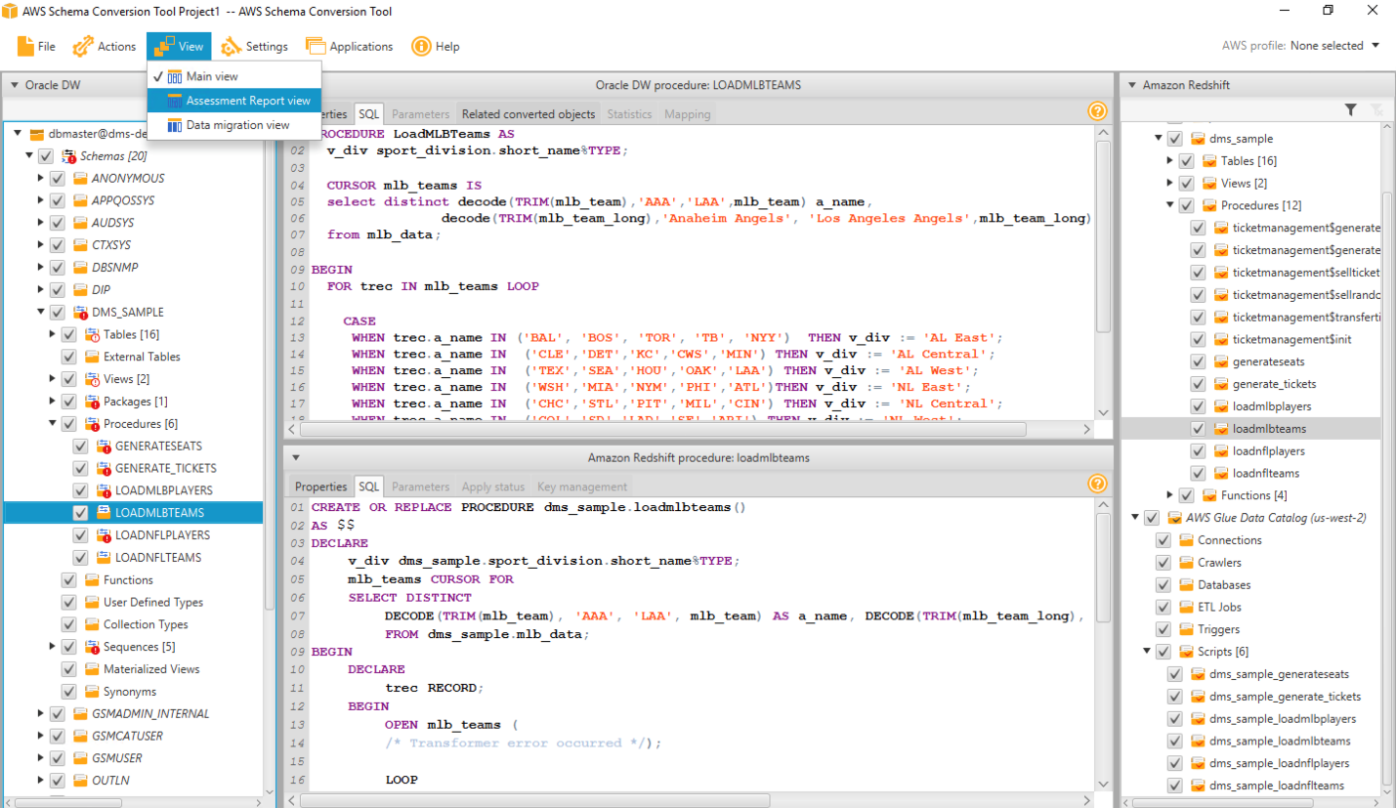

1.8. AWS SCT produces an executive summary describing the overall migration effort. It describes which objects could and couldn’t be migrated successfully using AWS SCT.

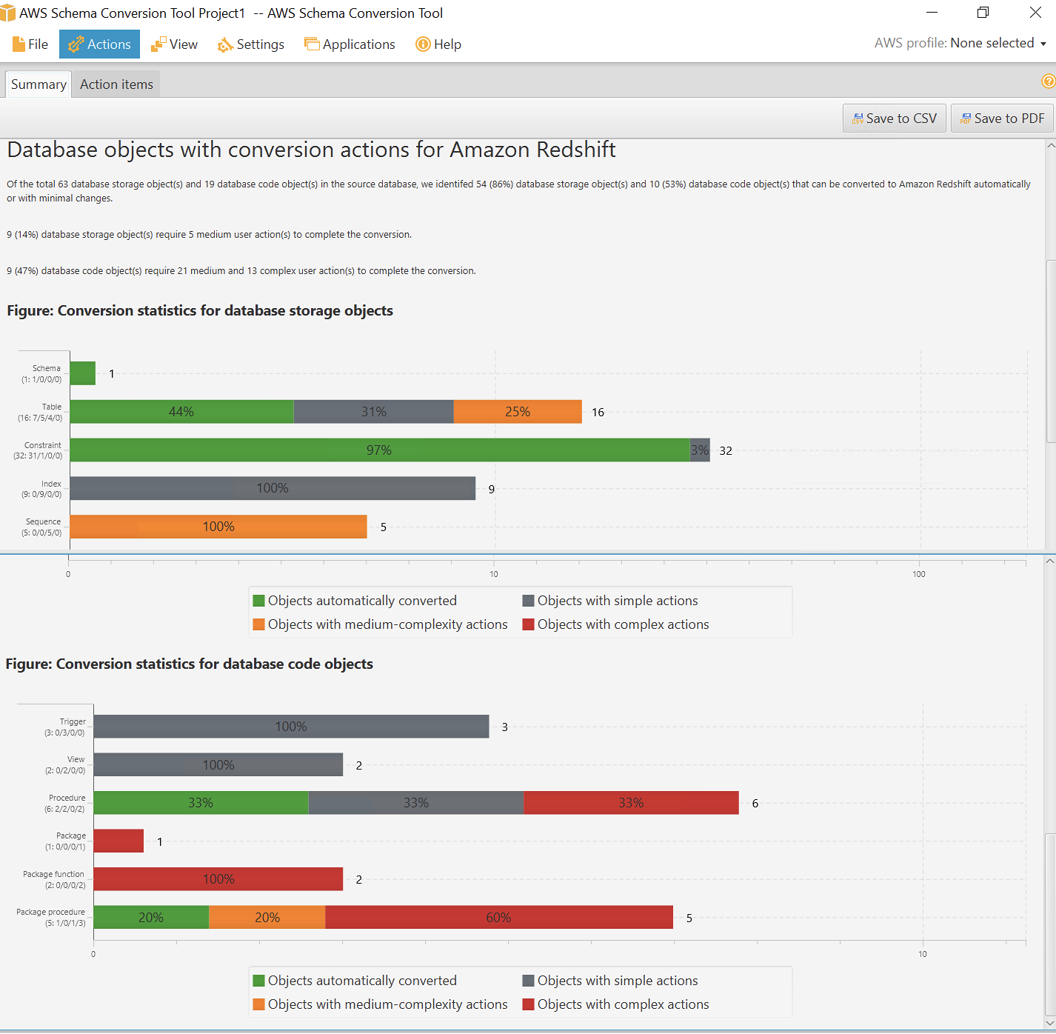

1.9 Click Action Items tab, which would show what action you need to take to migrate the unsuccessful objects. You may now examine stored procedure migration by this process.

1.10. From the left-hand screen, select the first stored procedure generateSeats, which shows Oracle/Redshift code side by side and also highlights all code that could not be migrated. On the top action items screen, you can also see the automated recommendations on how to resolve these code migrations.

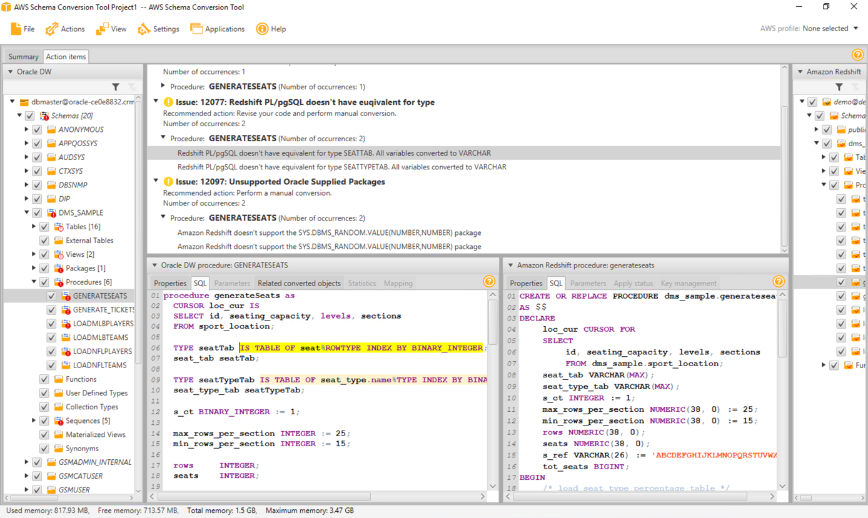

You can see that PL/SQL tables were used in this code, which is a vendor specific code and hence SCT could not convert it properly. In the real world we would need to manually fix the code based on the business requirements of this stored procedure. There is no need to fix anything for this lab.

1.11. Now, to save the successfully migrated objects in Redshift, you can click dms_sample on the right-hand side and click apply to database. Click the default options Yes when prompted on the next screens about are you sure.

[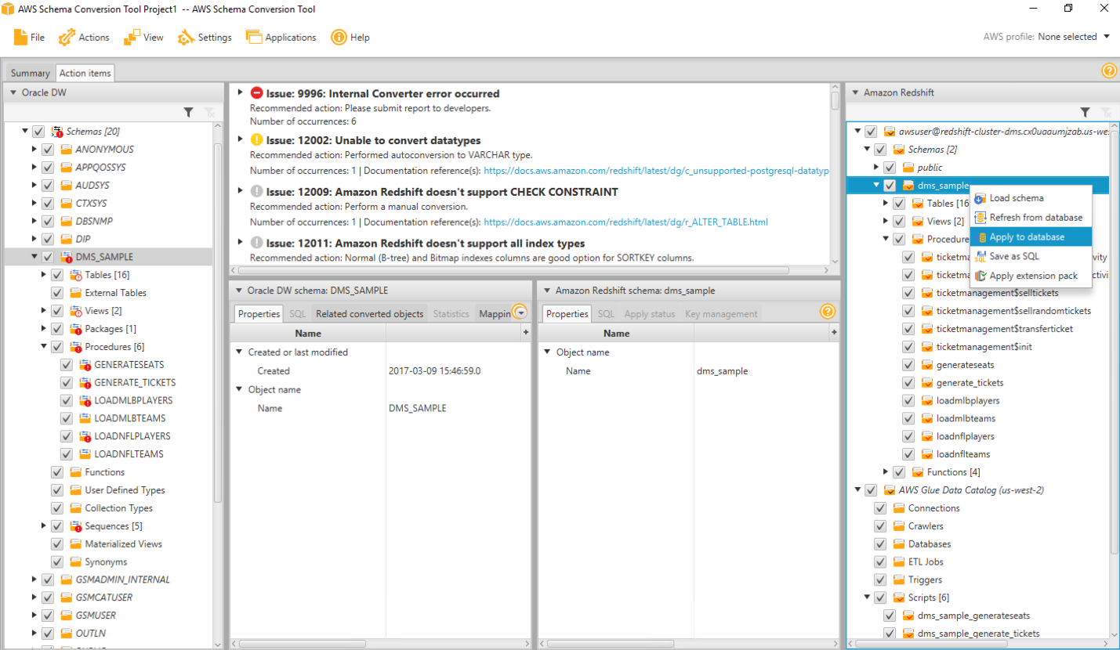](https://redshift-immersion.workshop.aws/images/lab11/sct6.png)

This will create all these structures in Redshift side, including table definitions, views, stored procedures and other objects.

1.12. Now, you may verify that in Redshift using Redshift query editor in AWS console or third-party IDE like SQL workbench, which is an open source JDBC IDE. Open SQL workbench from the taskbar shortcut, which opens the new connection window. Input below parameters and then click Test, which should be successful then Click OK.

Driver: Amazon Redshift

URL (Redshift JDBC Endpoint): <get from CF Output tab>

Username: demo

Password: <get from CF Output tab>

Autocommit: tick mark the checkbox

Read Only: untick the checkbox

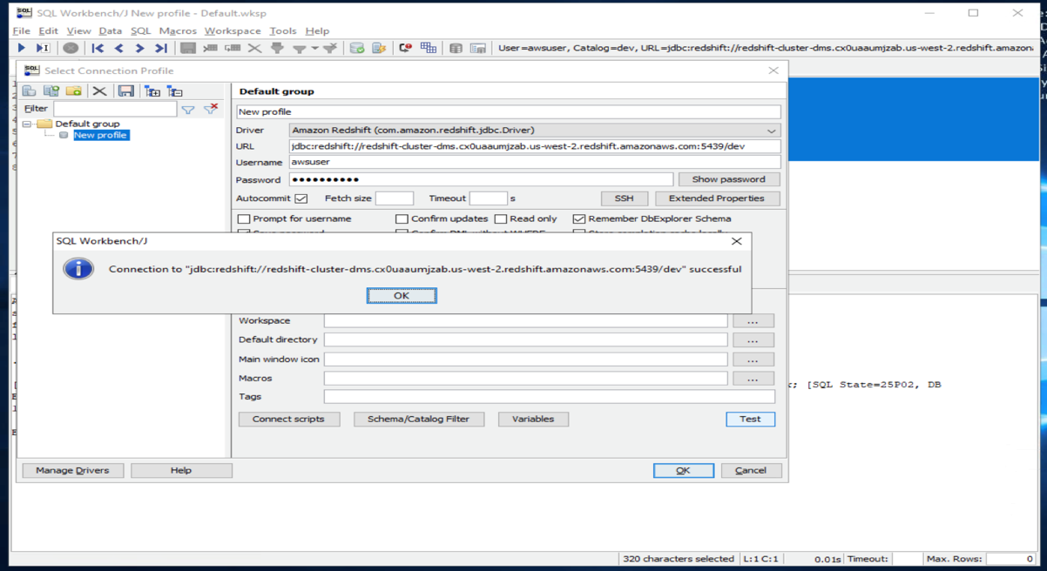

1.13. You may now examine the tables migrated to the dms_sample schema by running below query in SQL workbench:

select t.table_schema, t.table_name,i.tbl_rows

from svv_tables t left join svv_table_info i

on t.table_schema = i.schema and t.table_name = i.table

where t.table_type = 'BASE TABLE' and t.table_schema='dms_sample'

order by 1,2

All these tables should get successfully created in this Redshift schema, but as expected, there would not be any records in them. Next, you will migrate data from Oracle to Redshift using a service called AWS Database Migration Service (DMS)

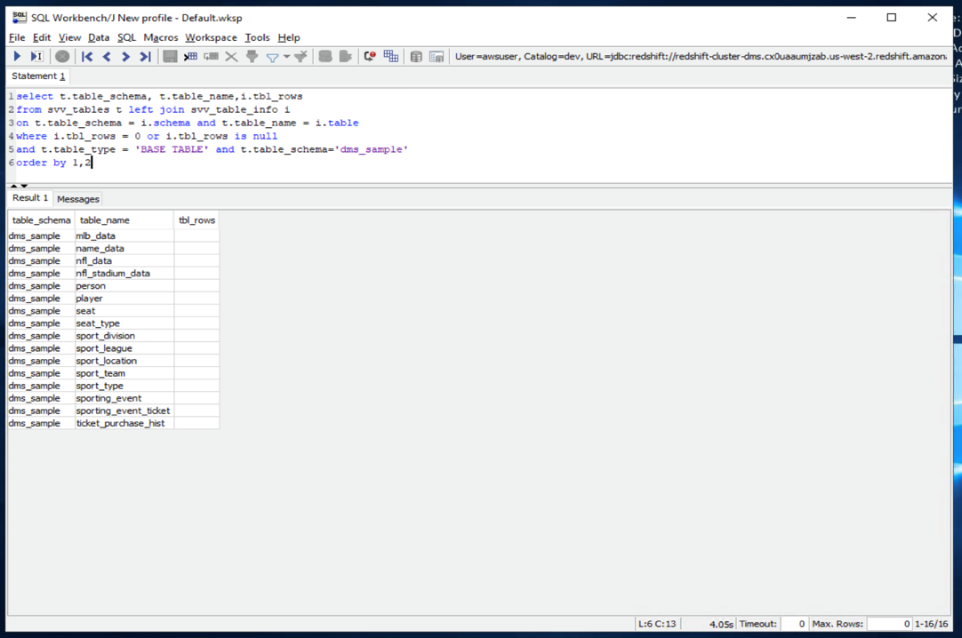

1.14. Before that, let us connect to Oracle and verify the dataset in Oracle. Open Oracle SQL Developer from the taskbar shortcut and click new connection button on left hand top side. Input below parameters:

name: Oracle

username: dbmaster

password: Password1

hostname: [Oracle-Endpoint] <get from CF Output tab>

port: 1521

sid: ORACLEDB

Click Test, which should be successful Click Connect and input above password if prompted again

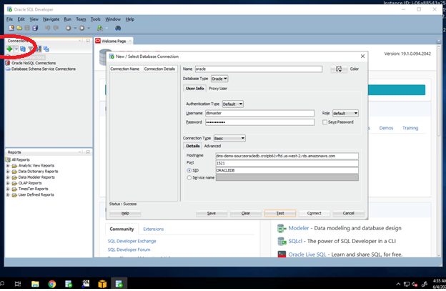

1.15. Let us check these tables in Oracle using Oracle SQL Developer. Open Oracle SQL Developer and execute this query:

select owner, table_name, nvl(num_rows,-1)

from all_tables where owner='DMS_SAMPLE'

order by 1,2

You can see decent number of records for this ticketing dataset. To migrate these records, you’ll be using AWS Database Migration Service(DMS).

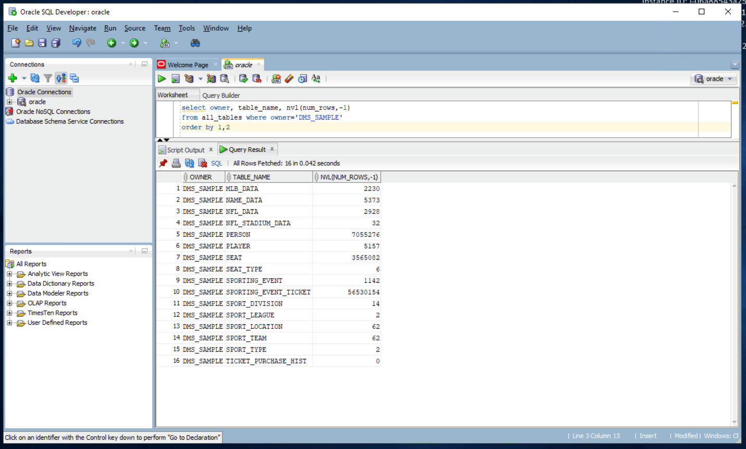

Note: For the sake of time, before starting the full load, let’s drop the biggest table involved in this migration (SPORTING_EVENT_TICKET). This will not impact the learning objectives of this lab; it will just save us about 15 minutes of time.

1.16. Still inside the SQL Developer console (Oracle Database), issue the following command:

drop table DMS_SAMPLE.SPORTING_EVENT_TICKET cascade constraints;

After dropping this table, Full Load migration should take only about 5 minutes to complete.

1.17. Before going to AWS Database Migration Service, you also need to provide access for DMS to use log miner, so that it can perform ongoing synch using Change Data Capture. You do not need to do this extra step if you only need one-time full load of the dataset. You’ll need to execute below script in Oracle SQL Developer to grant log miner access

@"C:\DMS Workshop\Scripts\ExecuteOracleSQL.sql"

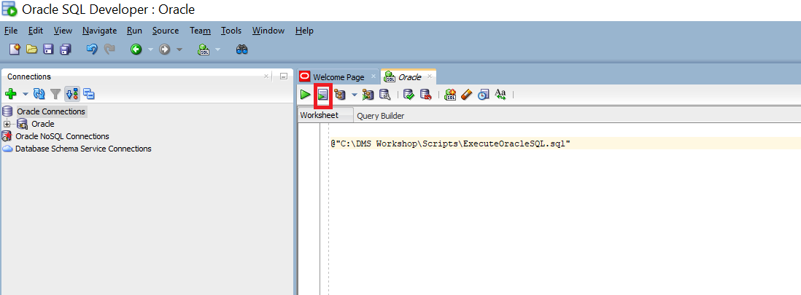

### **2. Migrate the data**

In this section, you’ll take care of migrating data from the source Oracle database to Amazon Redshift Data Warehouse using AWS Database Migration Service (DMS)

2.1. Open your web browser and login to AWS console. Navigate to DMS Service. For DMS, you first need to create a replication instance with suitable configuration; it would take care of all replication tasks from source to target databases. If you navigate to Replication instances, you can see an instance, which was taken care by our initial cloud formation template for this demo.

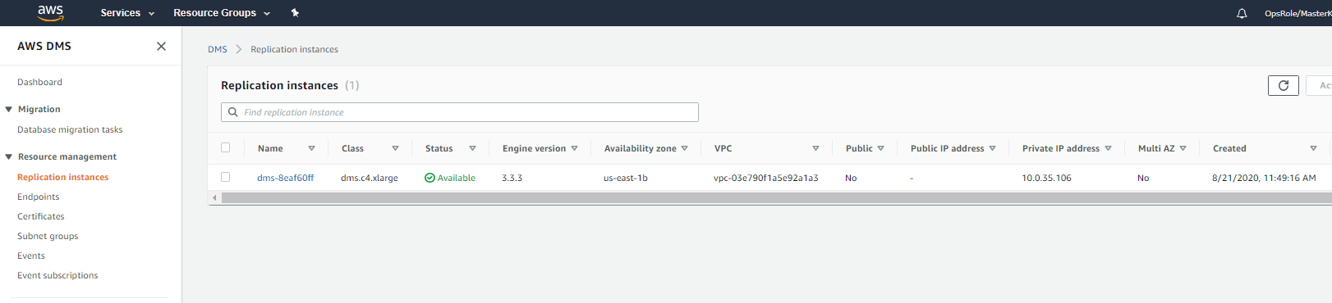

2.2. Next, you need to configure the source and target end-points. Click Endpoints and create Create endpoint

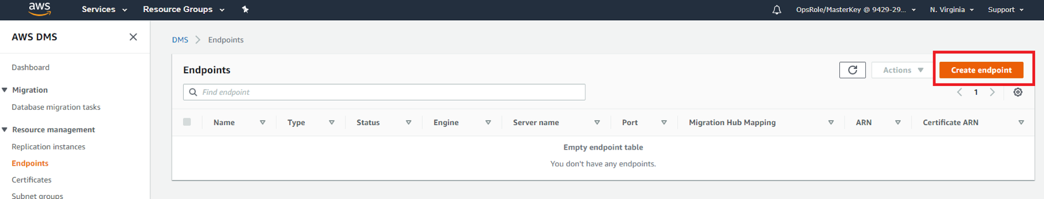

2.3. First, you’ll configure a source endpoint for Oracle. If you tick mark Select RDS DB instance, DMS automatically finds out our Oracle RDS instance, which you can select. Alternatively, you could have also entered the details manually as you would do for the target endpoint. For the source, keep Select RDS DB instance, selected so you only need to input the password, which is Password1.

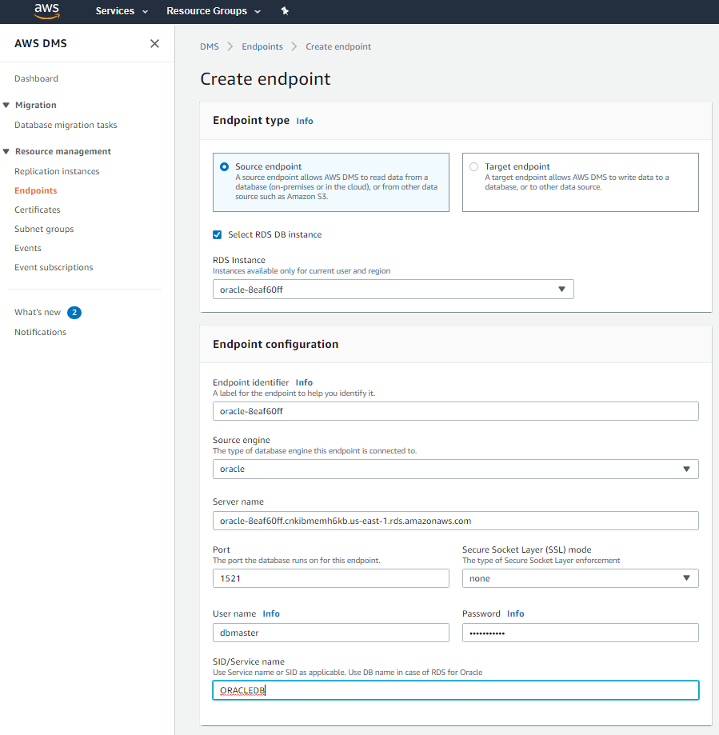

2.4. You’ll expand the option Test endpoint connection option and select our VPC (confirm in the CFN output) and then click Run test. Once the test is successful, click Create endpoint.

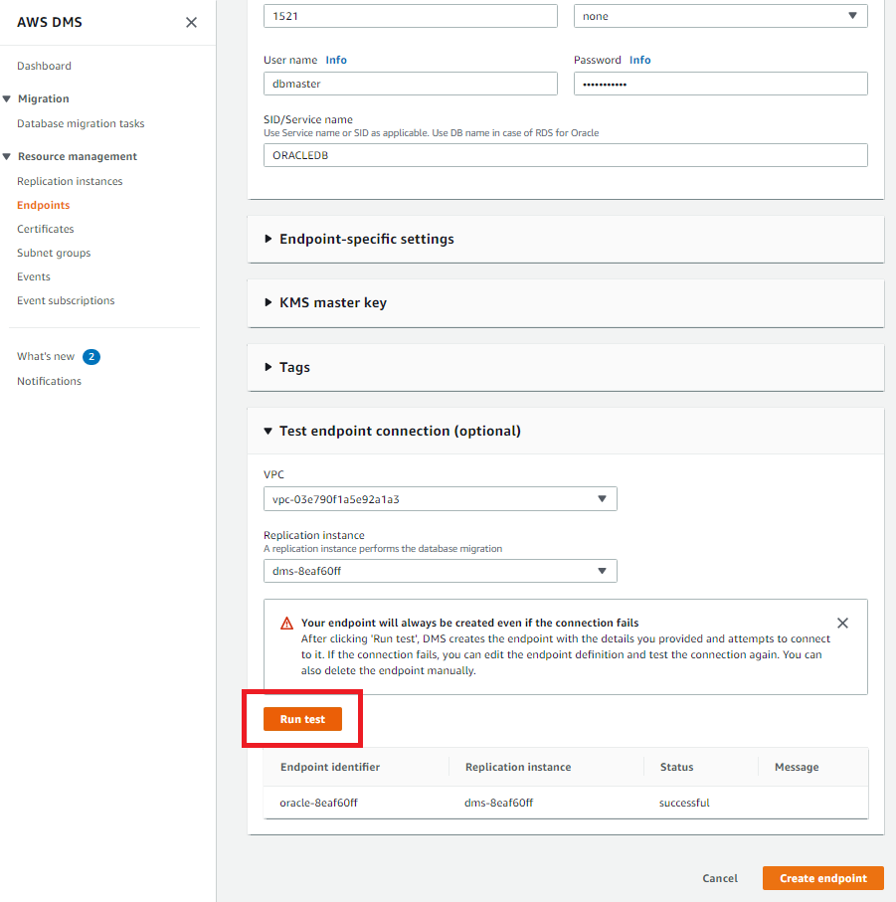

2.5. Next, you’ll configure a target endpoint for Redshift. Please input below:

Endpoint type: Target endpoint

Endpoint identifier: [input any value e.g. redshift]

Target engine: redshift

Server name: [Redshift-Endpoint] <get from CF Output tab>

Port: 5439

User name: demo

Password: <get from CF Output tab>

Database name: dev

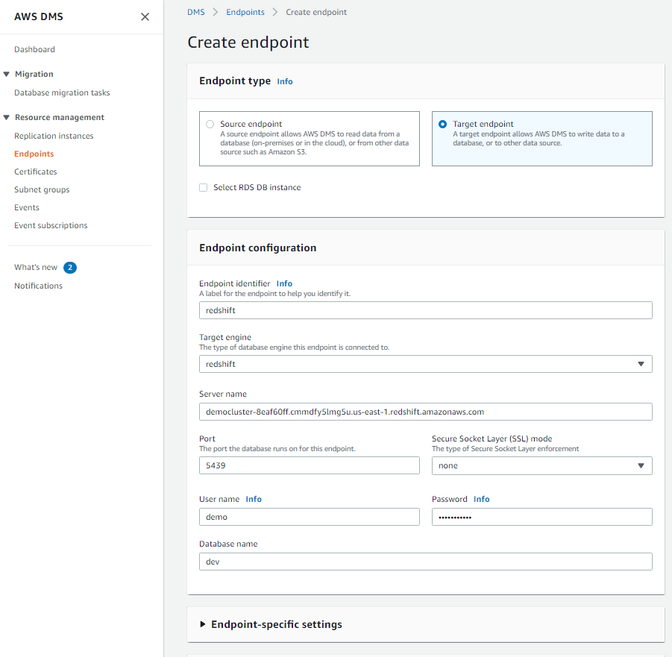

You’ll expand the option Test endpoint connection option and select our VPC and then click Run test. Once the test is successful, click Create endpoint.

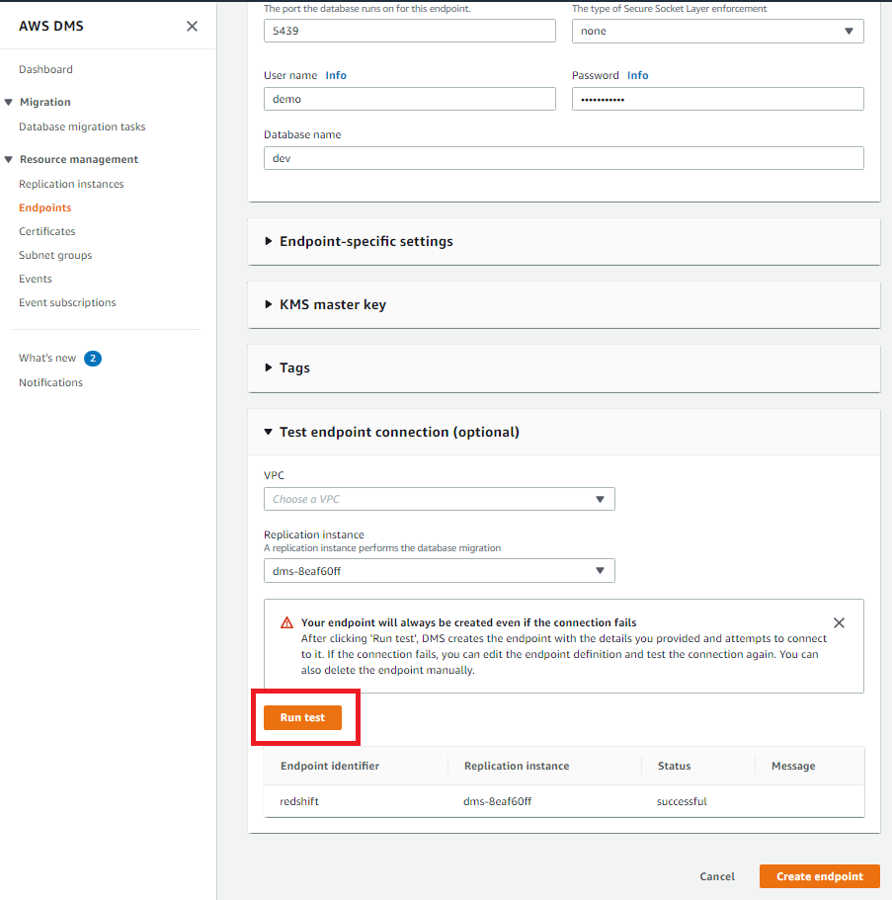

You can now see both our source and target endpoints.

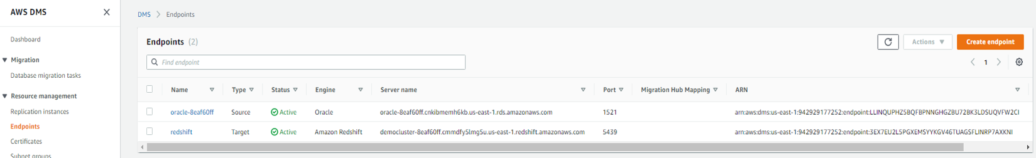

2.6. Our last configuration step is to create a replication task, which will take care of the data migration. Navigate to Database migration tasks and Click Create Task.

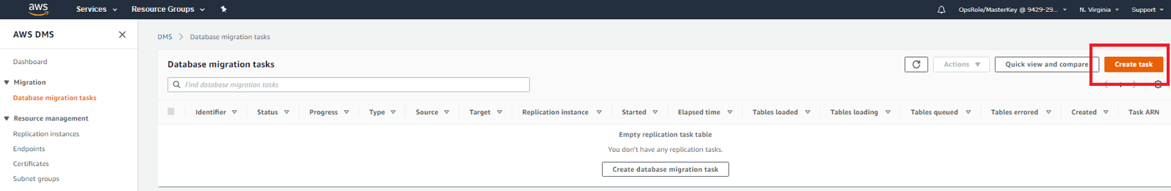

You need to provide any meaningful name in the Task identifier field. Then you can go with all defaults for instance and endpoints. For the option Migration type, click Migrate existing data and replicate existing changes.

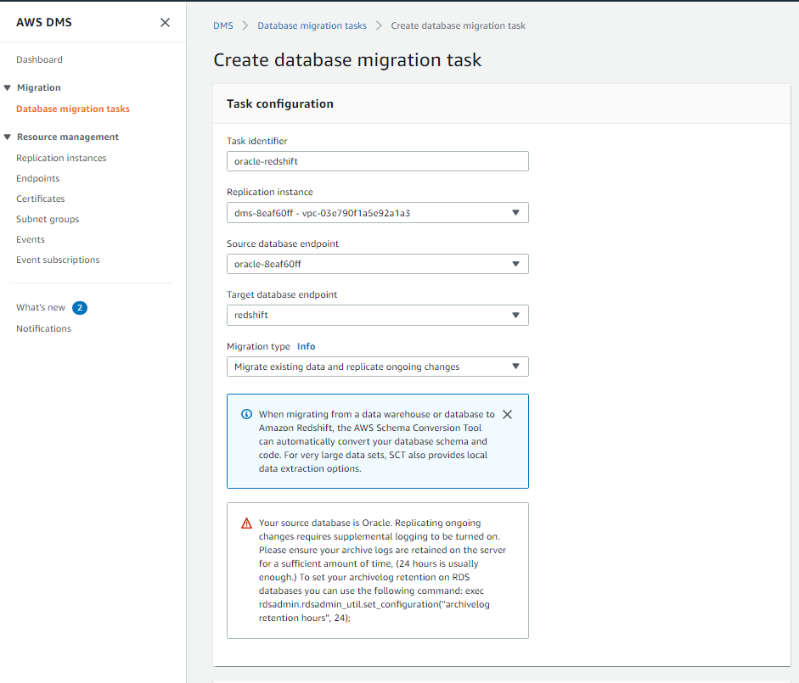

2.7. For the next tab of Task settings, you’ll go with all default option except for Target table preparation mode, where would select Do nothing as you already created all tables using AWS Schema conversion tool earlier.  
Also, tick Enable CloudWatch logs to view DMS logs in case something going wrong.

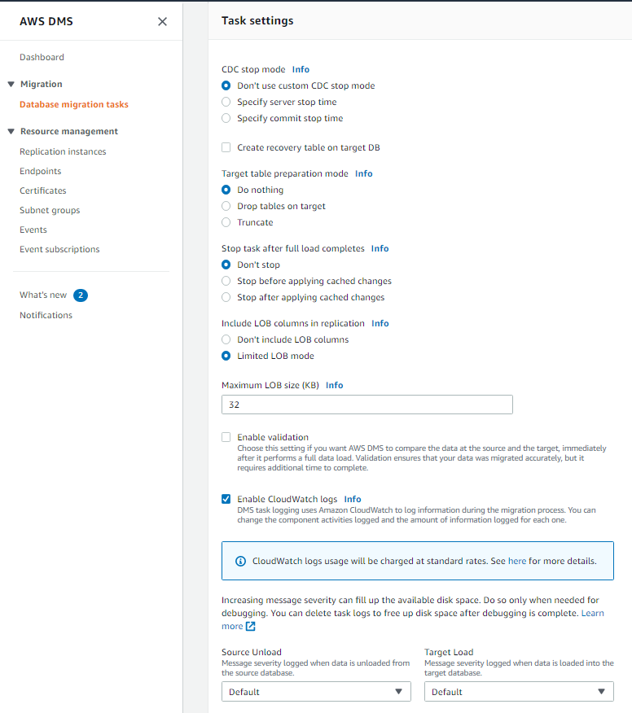

2.8. For the next tab of Table mappings, you need to click Add new selection rule. Then, for input Schema name, type DMS_SAMPLE (make sure it is all UPPERCASE!!). Keep the Transformation rules options as is for this demo, but it may be very useful if you need to do any transformations for schema, table or column names. Create the task and wait for it to be ready.

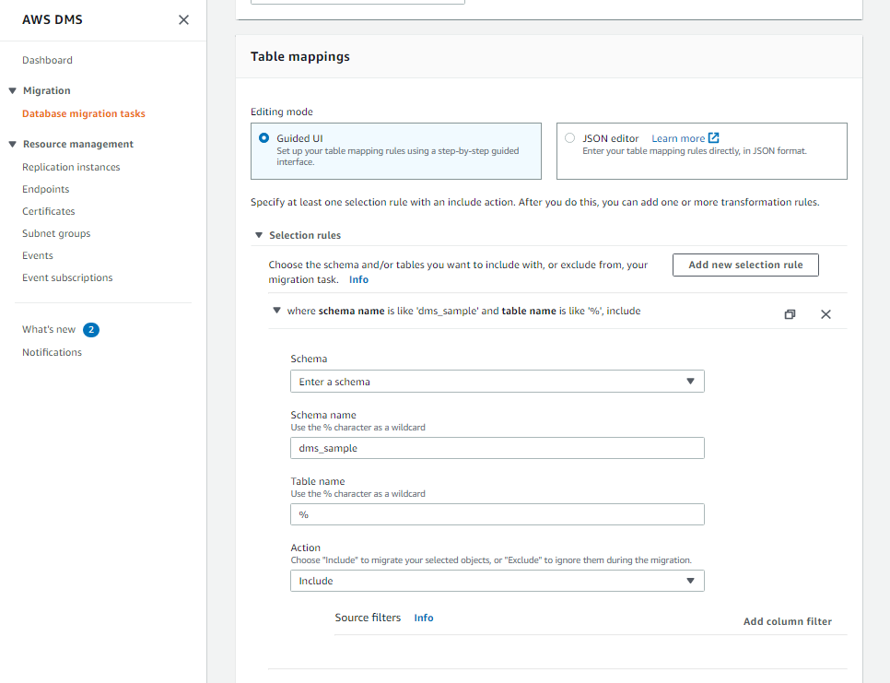

2.9. Now, you will run the migration, which will migrate all existing data from Oracle to Redshift and then also take care of Change data capture (CDC) to cater ongoing changes. Select the replication task > click Action > restart/resume

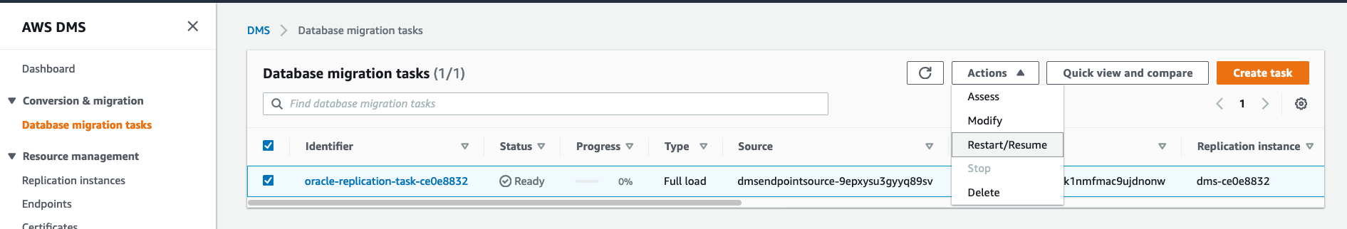

Keep monitoring the Status of the task. In the meantime, explore the DMS Task Console and tabs.

2.10. If you want to view the statistics of what data is getting transferred, you can go to this summary page allows him to view the statics of how many records are getting transferred via DMS. Click full load task and click table statistics

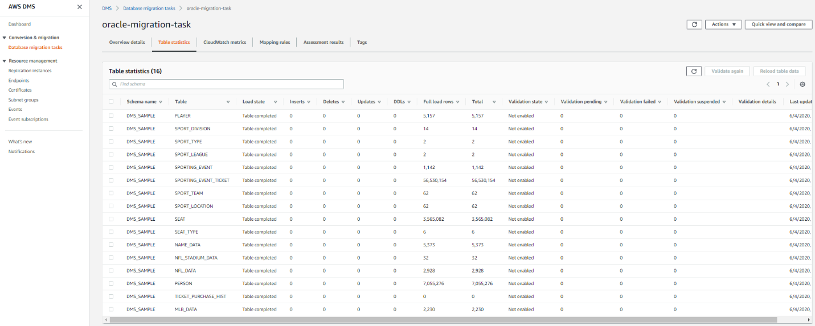

You may verify the same in SQL workbench. You can see all these tables got loaded with data in Redshift.  
Execute the same command executed earlier in SQL workbench to view the record count

select t.table_schema, t.table_name,i.tbl_rows

from svv_tables t left join svv_table_info i

on t.table_schema = i.schema and t.table_name = i.table

where t.table_type = 'BASE TABLE' and t.table_schema='dms_sample'

order by 1,2

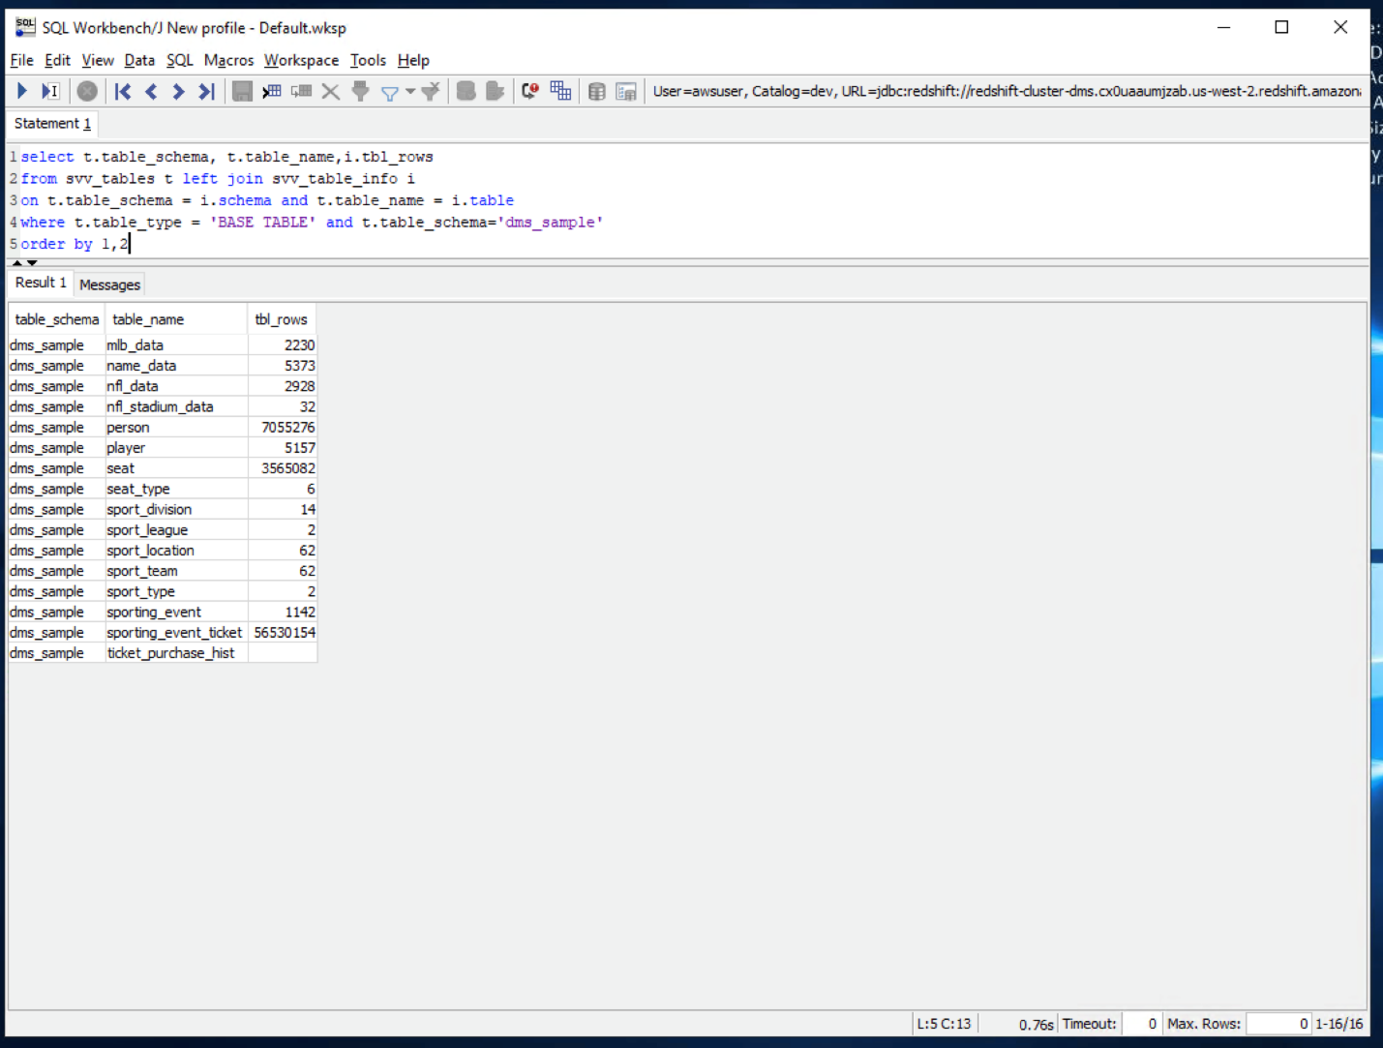

### **3 Keep the data in sync**

Now, you would verify the Change Data Capture (CDC) functionality of DMS to make sure ongoing changes are automatically replicated from Oracle to Redshift.

3.1. In our dataset, you have a table sport_type with just 2 records in it. You will now insert some records in it in Oracle side to verify if that gets replicated to Redshift. Execute below command in SQL workbench to view all records in sport_type table

select * from dms_sample.sport_type order by 1;

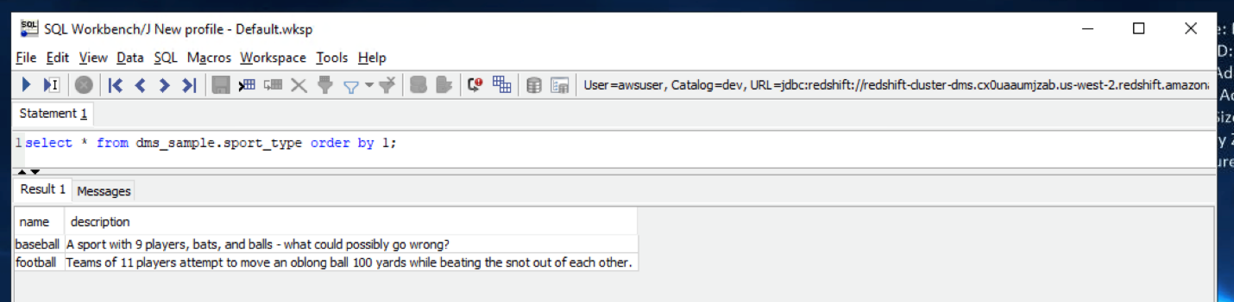

3.2. You may view data on this table in Oracle too, which should show same 2 records. Switch to Oracle SQL Developer and execute below command to view sport_type table

select * from dms_sample.sport_type order by 1;

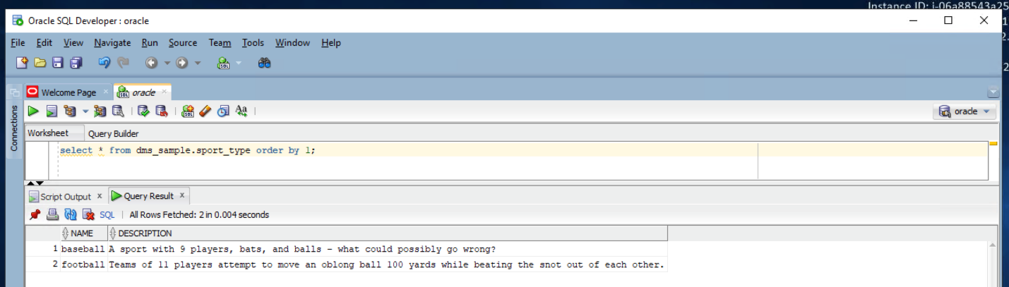

3.3. You want to confirm that the CDC process is operational. For that you will insert some records in the sport_type table in Oracle. Execute below command in Oracle SQL Developer to insert five records in sport_type table

INSERT ALL

INTO dms_sample.sport_type (name,description) VALUES ('hockey', 'A sport in which two teams play against each other by trying to more a puck into the opponents goal using a hockey stick')

INTO dms_sample.sport_type (name,description) VALUES ('basketball', 'A sport in which two teams of five players each that oppose one another shoot a basketball through the defenders hoop')

INTO dms_sample.sport_type (name,description) VALUES ('soccer','A sport played with a spherical ball between two teams of eleven players')

INTO dms_sample.sport_type (name,description) VALUES ('volleyball','two teams of six players are separated by a net and each team tries to score by grounding a ball on the others court')

INTO dms_sample.sport_type (name,description) VALUES ('cricket','A bat-and-ball game between two teams of eleven players on a field with a wicket at each end')

SELECT * FROM dual;

COMMIT;

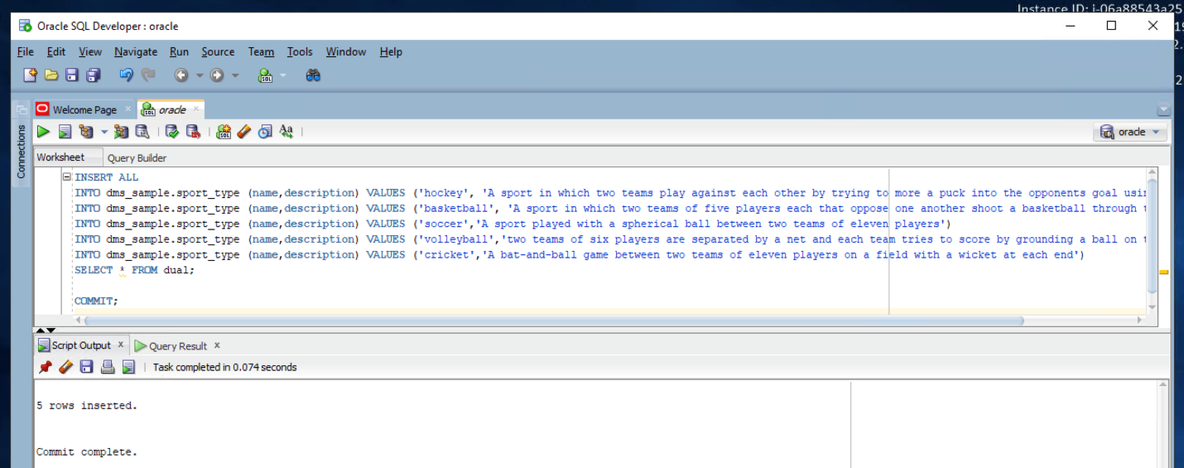

3.4. Execute below command in Oracle SQL Developer to view these new records sport_type table

select * from dms_sample.sport_type order by 1;

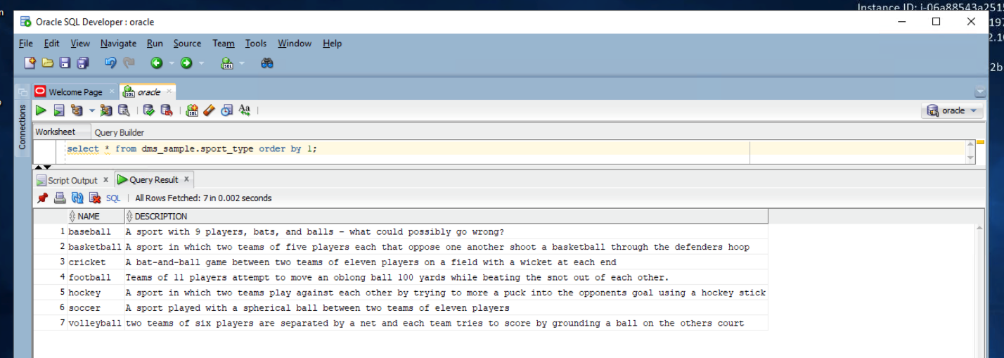

3.5. Now, go back to Redshift and see the records there. Execute below command in SQL workbench to view sport_type table:

select * from dms_sample.sport_type order by 1;

You would see the seven newly inserted records there too:

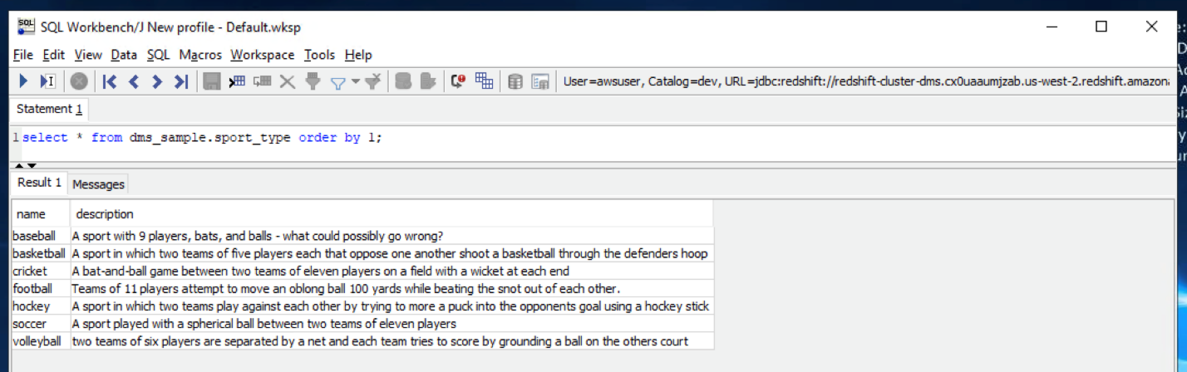

3.6. You may view the logs of the CDC process; you get to see a nice tabular metrics in the DMS console. Navigate to DMS service in AWS console and select the Ongoing Replication task and click table statistics

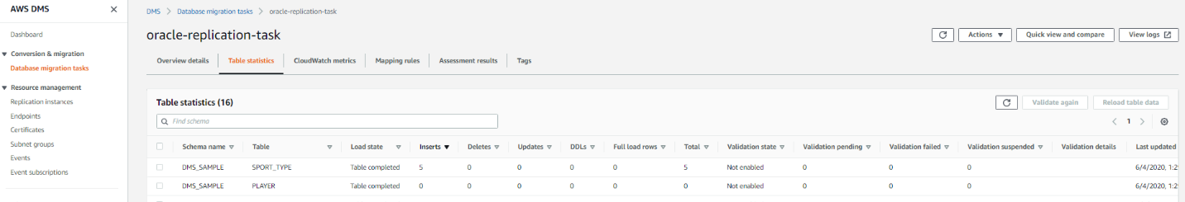

### **4. Data migration using AWS SCT Data Extractor Agents:**

In this section, you’ll take care of migrating data from the source tables in an Oracle database to Amazon Redshift Data Warehouse using AWS SCT extractor agents.

4.1 Start by truncating the two following tables. We will then re-migrate them, but this time, with the use of Extract Agents instead. In SQL Workbench run the following commands:

TRUNCATE TABLE DMS_SAMPLE.PERSON;  
TRUNCATE TABLE DMS_SAMPLE.SEAT;

4.2. Now, we need to create a IAM user for AWS Service profile used by SCT extractor agents. Open your web browser and login to AWS console. Navigate to IAM Service.

Create a user for AWS SCT extractor agents and give it Programmatic Access only. Select Attach Existing Policies Directly and add the policies for EC2, IAM, S3 and Redshift as shown in the picture below. Name it as sct-extractor-agent. Download the access key and secret key (Download .csv button) information of this user. You will use this user in AWS service profile in SCT later on.

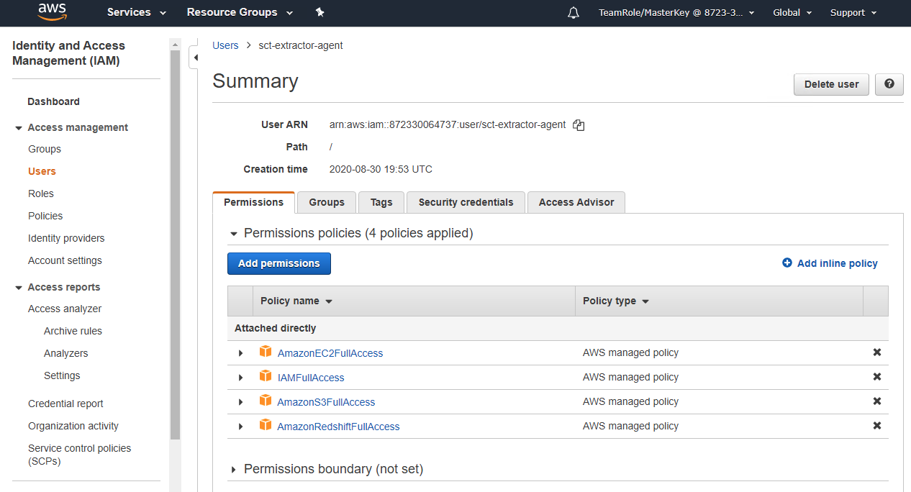

4.3. Next, on your Windows EC2 machine, you need to configure the settings.properties file at C:\Program Files\AWS SCT Data Extractor Agent. Remove all the existing content and replace it with the below configuration.

port=8192  
vendor=ORACLE  
driver.jars="C:\DMS Workshop\JDBC\ojdbc8.jar"  
redshift.driver.jars=C:\DMS Workshop\JDBC\RedshiftJDBC42-no-awssdk-1.2.43.1067.jar  
  
working.folder=C:/Users/developer  
  
ssl.option=OFF  
ssl.require.client.authentication=OFF

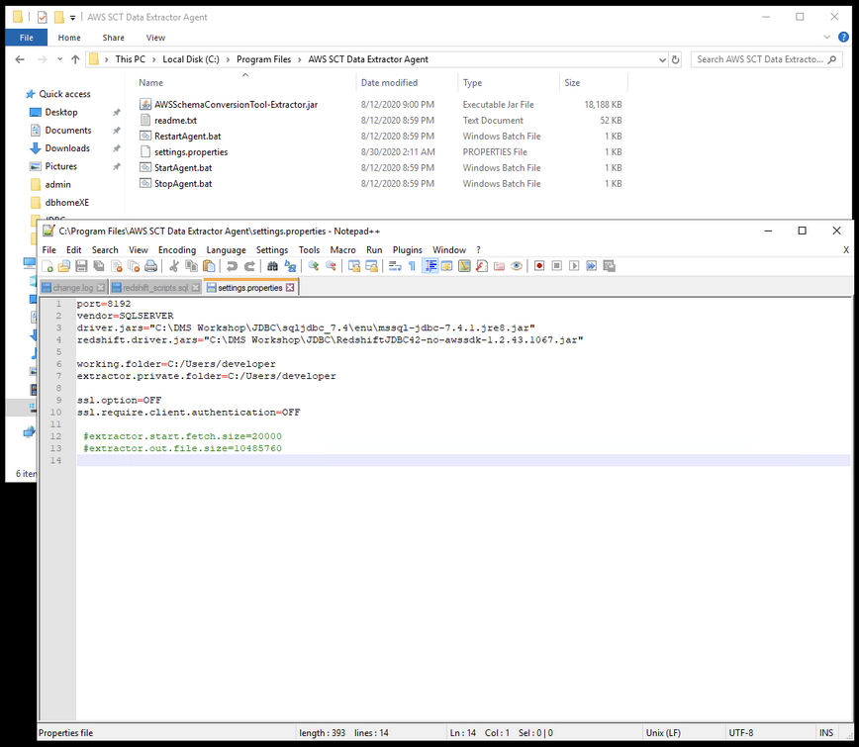

Note: You don’t need to perform this step if you reinstalled the SCT during this demo and configured the agent during installation.

4.4. Next you need to start the extractor agents background process (do this with “Run as Administrator”) by double clicking on StartAgent.bat at at C:\Program Files\AWS SCT Data Extractor Agent. Check the task scheduler to see if sct-extractor task is running to verify.

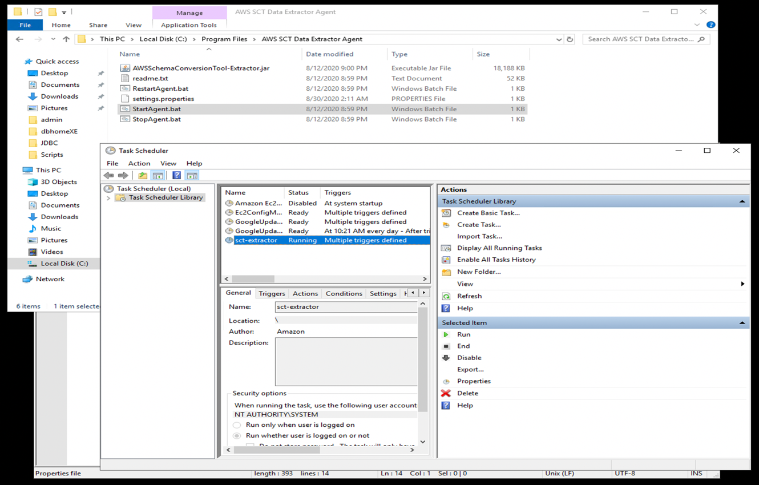

4.5. Back to the SCT tool, create an AWS Service profile by using the access key and secret of the IAM user created in previous step (you have downloaded the credentials details in step 4.2).

In SCT, go to settings and click Global Settings. Under AWS service profiles menu, provide the IAM user credentials. Also, take the opportunity to update the AWS S3 bucket folder with the bucket created by the CFN template.

**Note**: Go to S3 console and search for a bucket name that starts with rgs-task-data

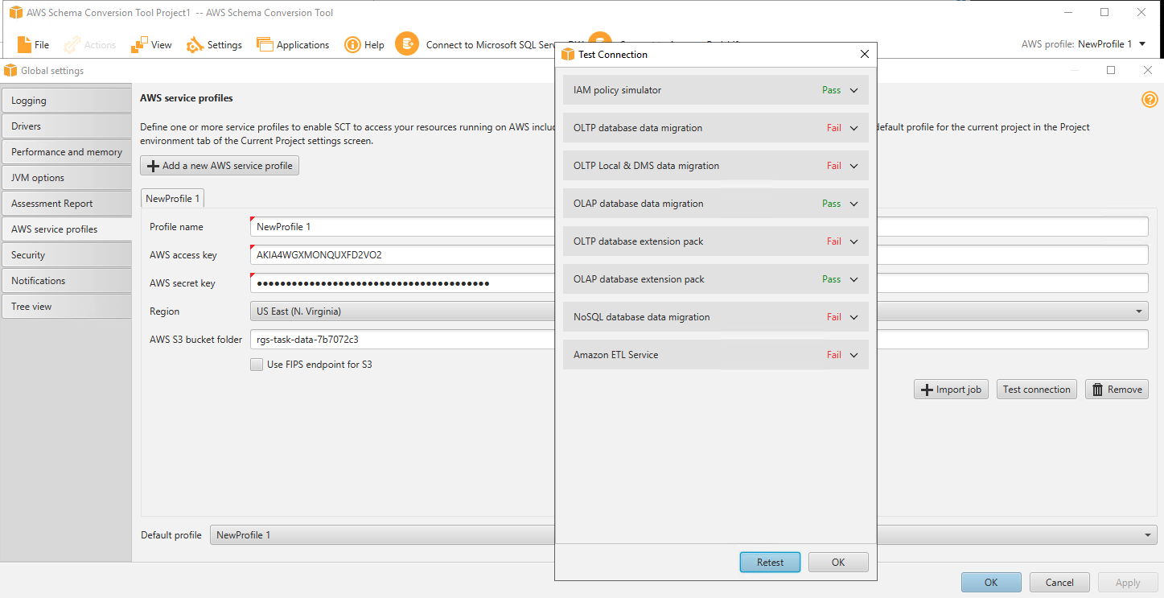

Then, click Test connection, compare the connection success with the ones shown in the image above. Click Apply and ok.

4.6. Within SCT, go to View and click on Data migration view.

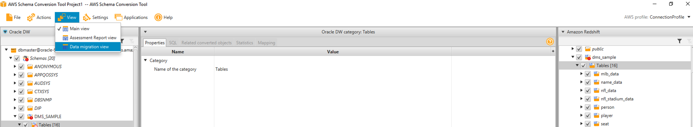

Here you need to register the extractor agents. Click on Register and fill out the information. Click on Test connection to verify agent connection.

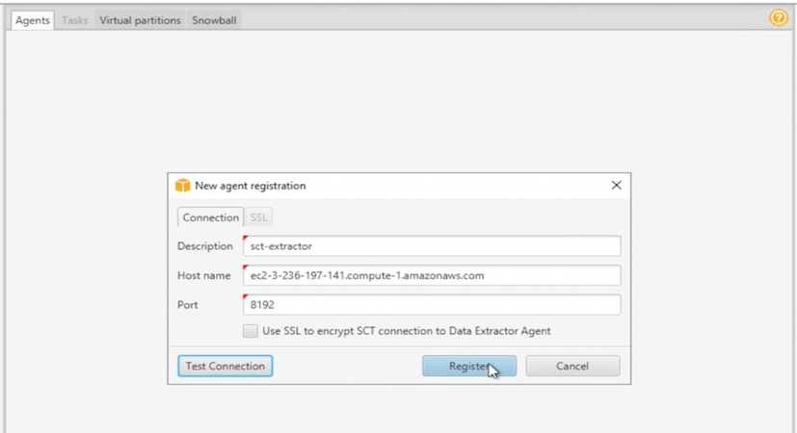

Note: The hostname here is the EC2’s endpoint you are connected to through RDP. Basically, the localhost, where the agent is configured and running. Get it from CFN output.

4.7. Once agent is registered, you need to create a task for the agent to perform the Extract, Upload and Copy operation on the tables we want. In this case, we want to re-migrate the tables Person and Seat which we have truncated in step 4.1.

On the source/left side, uncheck the DMS_SAMPLE schema and tick only the two tables below: DMS_SAMPLE.PERSON & DMS_SAMPLE.SEAT;

Then, right click where it says Tables[16] and choose Create local task option:

~~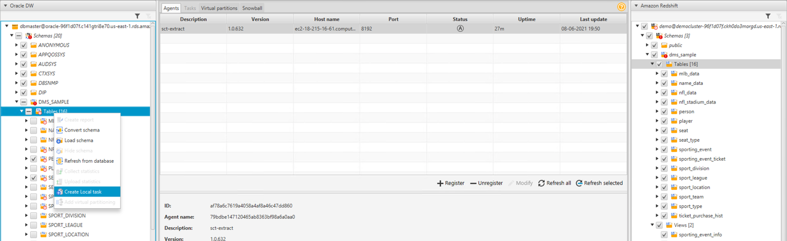~~

4.8. In the window of Create local task, choose Migration mode as Extract, upload and copy.

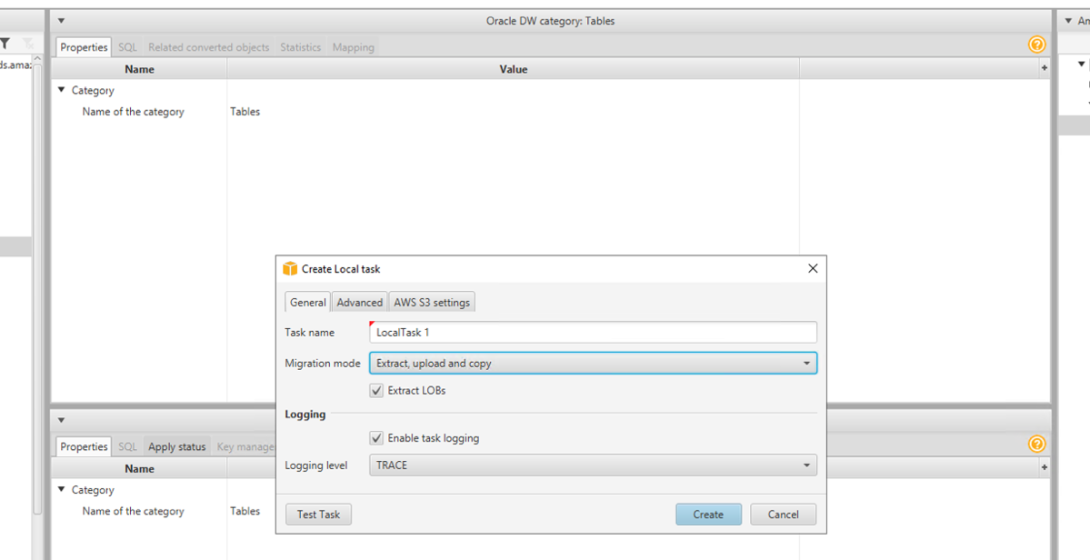

On the AWS S3 Settings tab, double check the S3 location. Make sure is the same bucket you updated previously in step 4.5.

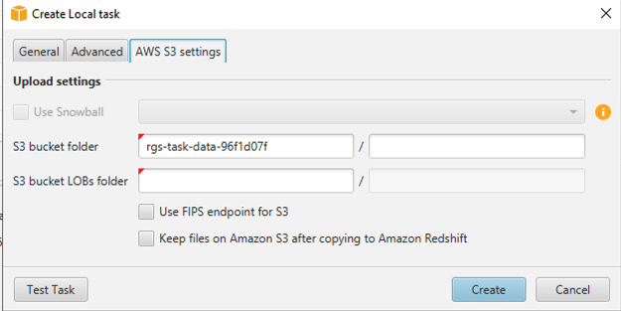

Click on Test Task. If pass, click on Create. Once the local task is created, select the root task (LocalTask1) at the top and click on the Start button to kick off the migration.

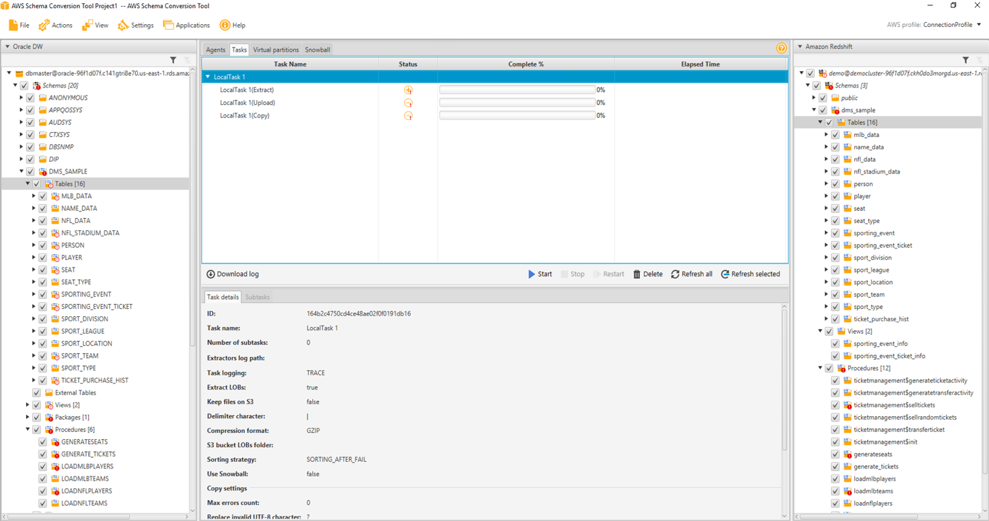

4.9. You can check the status of each task and subtasks (at table level) performed by SCT to migrate your data.

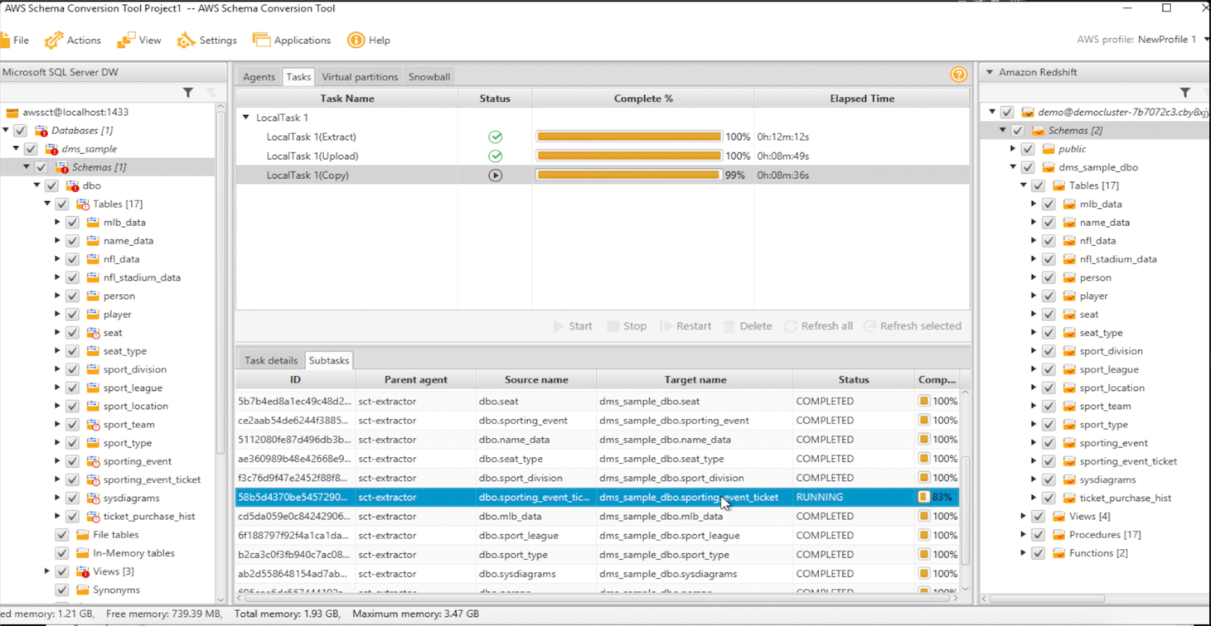

Each table will go through the Extract, Upload and Copy phases. However, you will notice that, after couple of minutes, the DMS_SAMPLE.SEAT table will fail during the Copy phase. The DMS_SAMPLE.PERSON will succeed. This is expected!

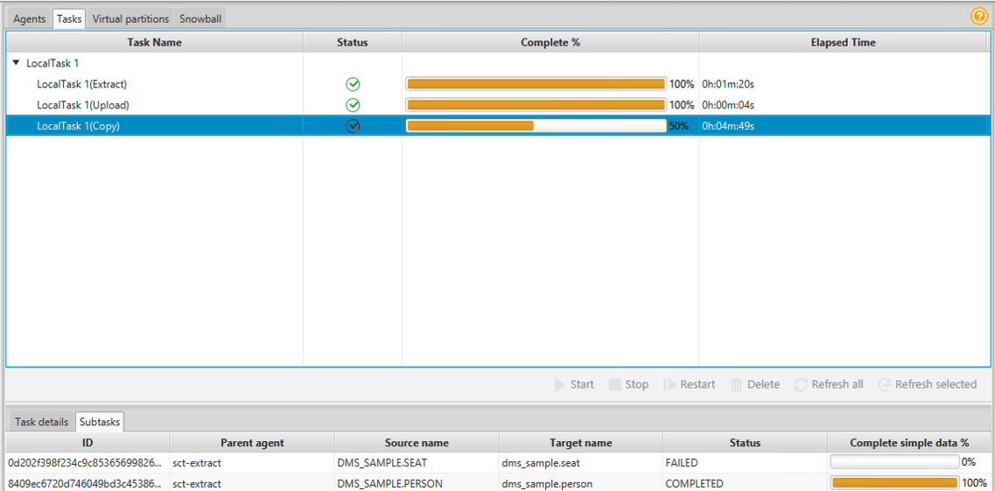

4.10. To understand what went wrong with the DMS_SAMPLE.SEAT we must view the logs of this migration, you can click on the Download log to save the logs at SCT installed location

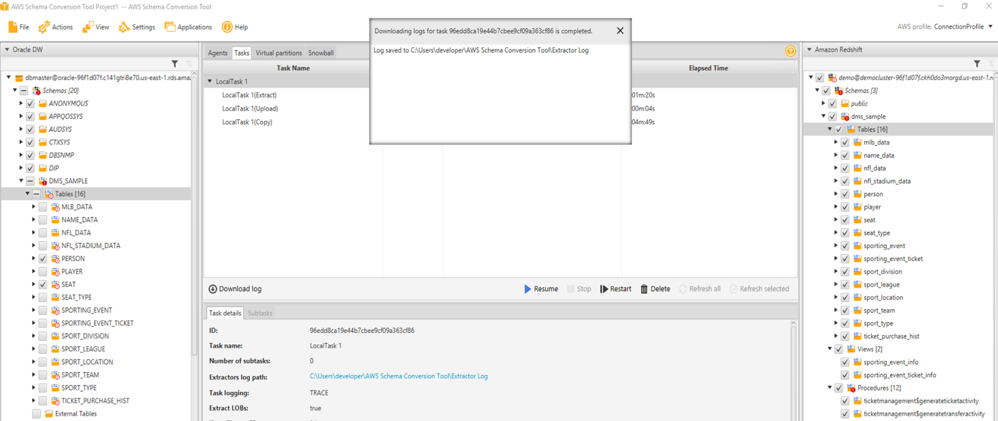

After unzipping the log and going through the last lines, we can see there was an issue with the COPY command. The log points us to the system table called STL_LOAD_ERRORS. Let’s have a look with the following query on SQL Workbench:

select starttime, line_number, colname, type, col_length, position, raw_line, err_code, err_reason from stl_load_errors order by starttime desc;

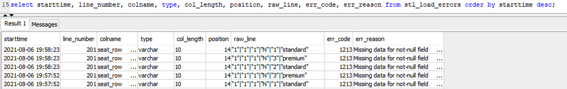

This error indicates that data is missing for the column seat_row that doesn’t allow NULL.

4.11. To fix this, let’s first drop the DMS_SAMPLE.SEAT table.

DROP TABLE DMS_SAMPLE.SEAT CASCADE;

Note: drop cascades to constraint set_seat_fk on table dms_sample.sporting_event_ticket

4.12. Then, we can go back to AWS SCT, verify and modify the DDL of the seat table to be more permissive regarding to NULL values for the seat_row column. Apply this table only, again to the target database.

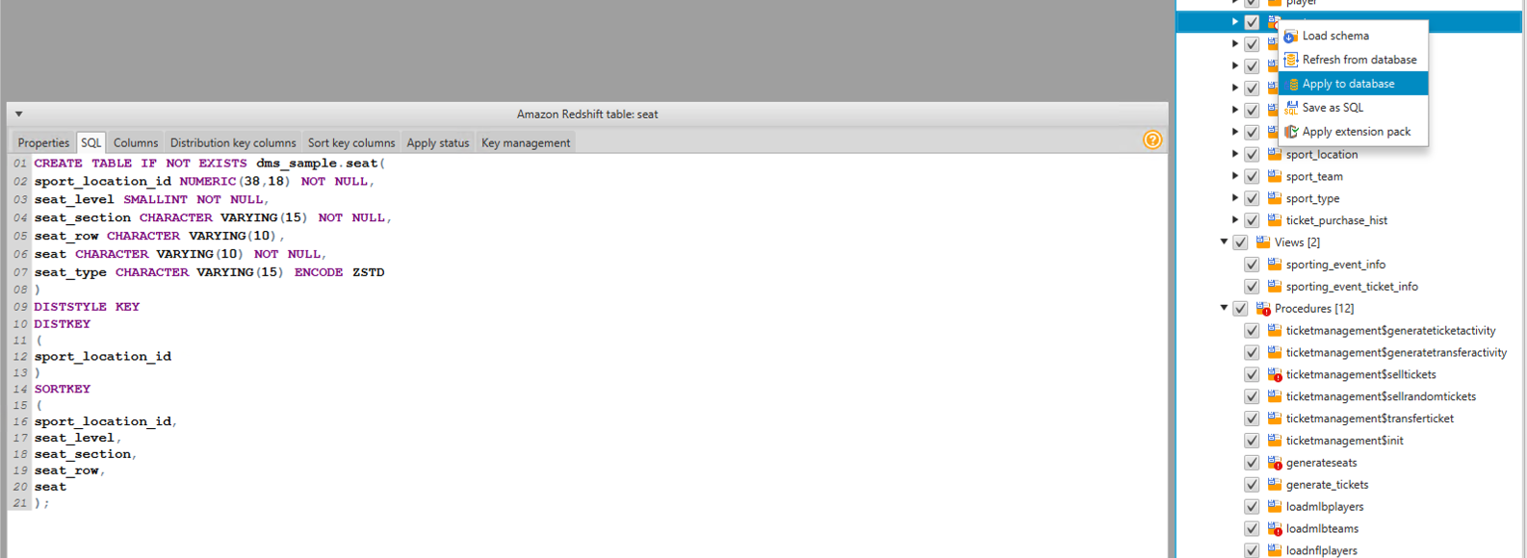

4.13. Now, we just need to create another task (LocalTask 2) just for the SEAT table, following the same previous steps (choosing Migration mode as Extract, upload and copy).

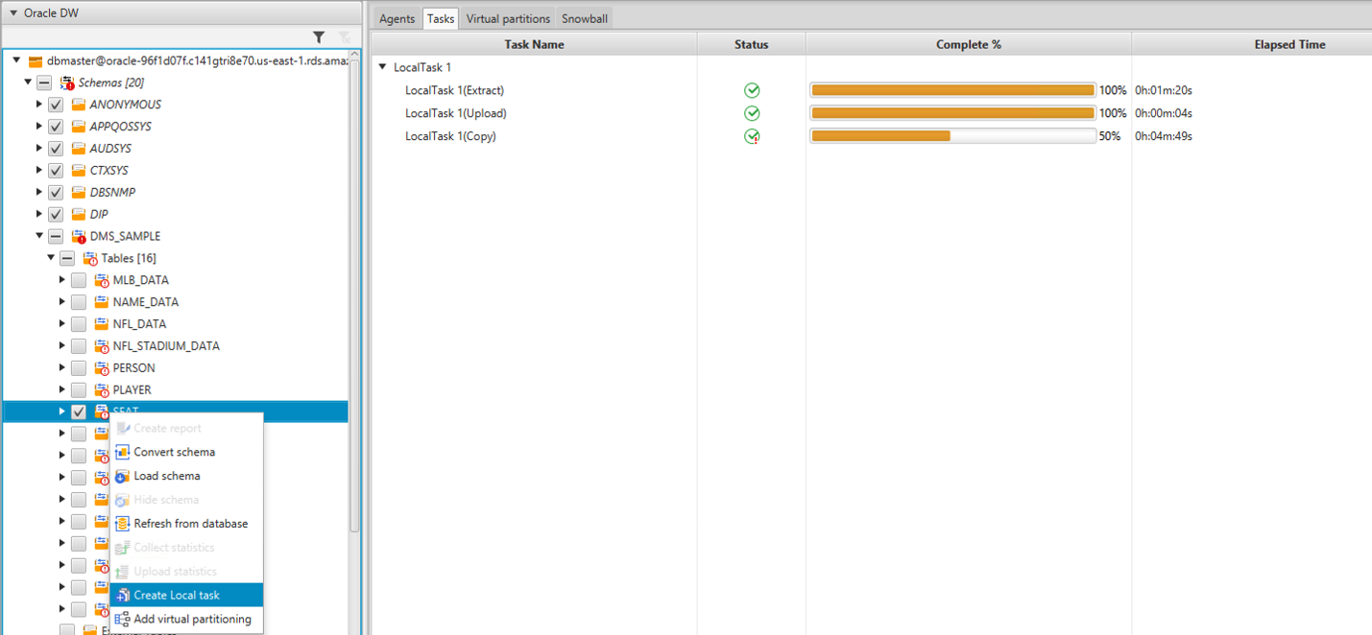

Once created, execute the LocalTask 2 and wait for it to complete:

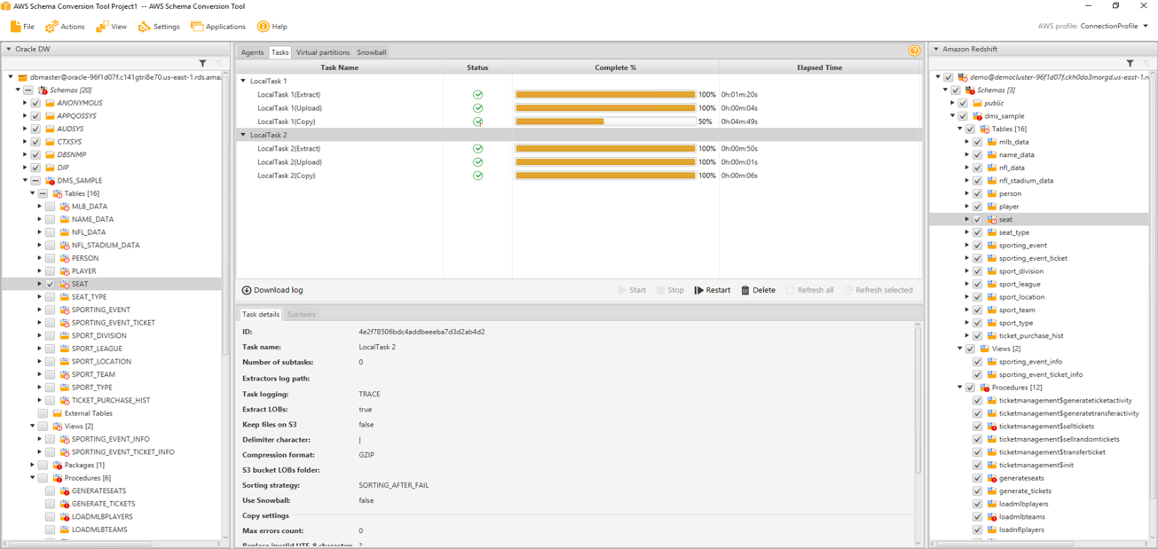

4.14. Finally, we can verify the final counts in the Redshift side for DMS_SAMPLE.SEAT and DMS_SAMPLE.PERSON tables. Execute the same command executed earlier in SQL workbench to view the record count

select t.table_schema, t.table_name,i.tbl_rows

from svv_tables t left join svv_table_info i

on t.table_schema = i.schema and t.table_name = i.table

where t.table_type = 'BASE TABLE' and t.table_schema='dms_sample'

order by 1,2

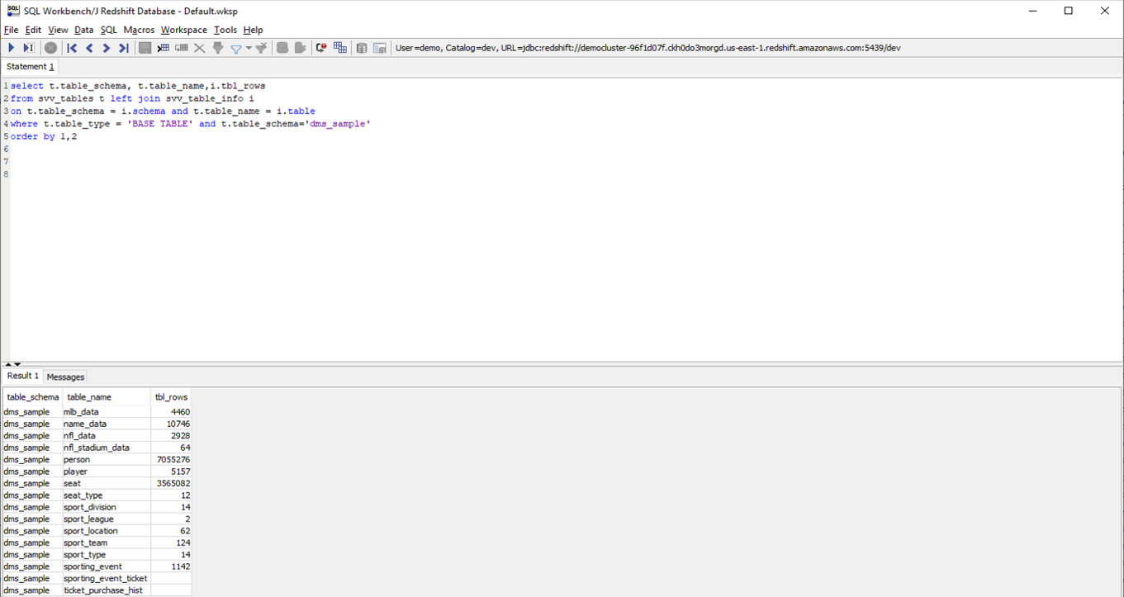

## Before You Leave - Cleanup the Lab Resources:

B**efore attempting to delete the Stack itself, do the following to avoid errors during stack deletion:**  
  
**First Stop then Delete the DMS Task. Then, Delete the two created Endpoints.**  
  
After that you are safe to go ahead and delete the Stack. It will automatically delete all the created resources.  
  
Note: Stack Deletion process takes time, keep an eye on it in case it fails. You don't want to end up with resources running that hasn't been properly deleted which will cost you money!!!